VIETNAM NATIONAL UNIVERSITY, HO CHI MINH CITY

UNIVERSITY OF INFORMATION TECHNOLOGY

FACULTY OF COMPUTER ENGINEERING



**AN APPLICATION OF AUDIO PROCESSING ON FPGA USING VERILOG**

(XỬ LÝ ÂM THANH TRÊN FPGA SỬ DỤNG VERILOG)

MENTOR: Ms. Hồ Ngọc Diễm

Bùi Văn Thi 21522612

Nguyễn Minh Lộc 21522293

Nguyễn Thành Tài 21522568

CLASS: CE213.O11.MTCL

*HO CHI MINH CITY, October 2023*

**Content Table:**

**Chapter 1: Introduction…………………………………………….3**

**Chapter 2: Overview………………………………………………..5**

**Chapter 3: Theory of sound………………………………………...7**

**3.1: Sound and sound waves………………………………….7**

**3.2: Frequency and amplitude of sound……………………..7**

**3.3: Sound coordination………………………………………9**

**3.4: Perception of sound………………………………………9**

**3.5: Application of sound theory……………………………..9**

**3.6: Digital Audio Representation…………………………..10**

**3.7: Digital audio format and encoding…………………….12**

**3.8: Digital audio processing and reproduction……………13**

**3.9: Applications of digital audio……………………………15**

**Chapter 4: KIT DE2 70 Cyclone II and Wolfson WM8731……..17**

**4.1: FPGA technology………………………………………..17**

**4.2: Some FPGA kits…………………………………………19**

**4.3 DE2………………………………………………………..21**

**4.3.1: Overview……………………………………………….21**

**4.3.2: Diagram………………………………………………..22**

**4.4. Wolfson WM8731 audio chip…………………………...24**

**Chapter 5: Building the system…………………………………...44**

**Chapter 6: System deployment…………………………………....70**

**Chapter 7: Experimental results, evaluation and development direction…………………………………………………………….86**

**Chapter 1: Introduction**

**1.1 Reason for choosing the topic**

Human history has gone through many revolutions in science and technology. The spirit of creative exploration helps people increasingly innovate and find new tools and new ways to conquer nature, bringing new eras to humanity.

In recent years, microelectronics technology has developed very strongly. The advent of large, extremely large microchips with rapidly decreasing prices and increasing programmability has brought about profound changes in the electronics engineering industry. The world's industry has achieved great achievements thanks to the progressive application of science - engineering and technology. Machines have replaced people in many difficult jobs and are gradually replacing them in production labor.

Microcontroller programming is an indispensable part when manufacturing automatic machines. In a machine, if the mechanical part creates a shape and a flexible operating structure, the programming part and electronic circuits are like a brain that controls those activities. In today's electronic technology industry, DSP (Digital Signal Processing) audio signal processing technology is exploding rapidly and is highly developed. Even higher, FPGA technology has been applied in many areas of life and society.

Every day we hear a lot of sounds from many different sources such as human voices, music from speakers, headphones, sounds from vehicles and public transportation,... All of these sound sources are the same. together create a rich and diverse sound picture in our daily lives. Therefore, with the knowledge we have learned in class and wanting to apply that knowledge into practice, we have chosen the topic:

**“Sound Processing With FPGA”**

**1.2 Objectives for the project**

This project aims to develop a high-performance audio processing system using FPGA (Field-Programmable Gate Array). The main goal is to optimize real-time audio processing with the flexibility and customization of the FPGA.

**Chapter 2: Overview**

- Audio processing using FPGA (Field-Programmable Gate Array) is an important and challenging field in embedded systems and signal processing. Here are the ways in which FPGA processes audio signals:

* **Flexible Real-Time Audio Processing:**
* **Recording:** FPGA can be used in combination with recording circuits and ADC (Analog-to-Digital Converter) to convert audio signals from analog to digital form.
* **Real-time audio processing:** FPGAs provide a flexible platform for implementing audio processing algorithms such as digital filters, fast Fourier transforms (FFTs), and more complex algorithms.
* **Classification and Identification of sounds:**
* FPGAs can integrate machine learning models such as artificial neural networks to perform voice recognition, sound classification, or identify special sounds.
* **Performance Optimization:**
* The flexibility of FPGA allows for optimized performance in audio processing. FPGA devices can often be reprogrammed to adapt to the specific requirements of the application.
* Using SoC (System-on-Chip) architecture can integrate CPU and special hardware for audio processing, reducing latency and increasing processing speed.
* **User Interface Development:**
* FPGAs can be combined with microcontrollers to create user interfaces through communication ports such as UART or Ethernet.
* The user interface may provide options such as volume adjustment, audio processing mode, and other settings.
* **Integration with Other Systems:**
* FPGA can connect to other components of the system through standard communications such as I2C, SPI, to share data and control.
* Integrating FPGA into larger systems helps optimize resources and increase compatibility.
* **Facing Latency Challenges:**
* Latency is an important challenge in audio processing. The hardware and software design on the FPGA needs to be optimized to reduce latency and ensure real-time performance.
* **Integration Techniques and Hardware/Software Options:**
* The combination of hardware and software on the FPGA provides flexibility and customization. Some functions can be implemented in hardware to achieve high performance, while other functions can be implemented in software to achieve high flexibility.

**Chapter 3: Theory of sound**

1. **Sound and SoundWave:**

Sound is a form of energy created through vibrations of matter and has the ability to stimulate human senses to create sound. When an object vibrates, it creates vibrations in the surrounding environment, changing the pressure of that environment and creating sound waves.

Sound waves are the propagation of these changes through a medium, usually air, water or other materials. When an object vibrates, it causes the molecules around it to vibrate, creating a pressure wave. Sound waves propagate as mechanical waves and can propagate through the medium without moving its own matter. When the sound wave reaches the human ear, it creates oscillations in the eardrum of the ear, and through During this process, it is converted into nerve impulses that the brain then decodes into sounds we can hear.

The special feature of sound waves is that they have the ability to propagate through many different types of materials, and the speed of propagation often depends on the type of material the wave is traveling through.

1. **Frequency and amplitude of sound:**

**2.1 Frequency:**

The frequency of a sound measures the number of oscillations or cycles of the sound per unit of time, measured in units of hertz (Hz).  
Frequency is linked to our perception of highs and lows.  
**High Sound**: Higher frequencies (e.g. above 2000 Hz) produce high-pitched sounds, such as a small bell, a dog barking, or a cicada chirping.

**Low Sound**: Lower frequencies (e.g. below 200Hz) create deep sounds, like drums, thunder, or bass in music.  
Sound frequency affects our perception of sound, and each person has the ability to perceive different frequencies with different sensitivity. For example, children often have a higher ability to hear higher frequencies than adults, while the elderly often have a reduced ability to hear at high frequencies.  
The human ear can hear frequencies ranging from 20Hz to 20kHz; beyond this threshold, the human ear will not hear sound. It should be noted that this range may vary from person to person due to differences in age, health, and other factors.

**2.2 Amplitude:**Amplitude of sound is a measure of the degree of variation in the loudness or strength of the sound. It represents the fluctuation of sound pressure, i.e. the difference between the maximum pressure and minimum pressure of sound during one period of oscillation.  
In a sound wave diagram, amplitude is represented by the height of the wave. If the sound wave is high, it means the amplitude is large, and if the sound wave is low, the amplitude is also low.  
Amplitude determines the loudness of the sound we hear. The greater the amplitude, the louder and stronger the sound. For example, in the case of a speaker, a large amplitude can produce a louder sound, while a small amplitude will produce a weaker sound.  
The commonly used unit of amplitude measurement is the decibel (dB) in sound, and amplitude is measured from the minimum sound level that can be heard (auditory threshold) to the highest sound level that the human ear can hear tolerable without causing harm.  
The amplitude range that the human ear can hear without causing harm is divided into two thresholds:

* Pain threshold: About 120 dB or more can cause pain to the human ear.
* Usual safe threshold: Usually around 85 dB to 90 dB over a long period of time (8 hours is the safe level), above this can cause damage to hearing with continuous exposure.

Listening to music at high volumes or being exposed to excessively loud sounds for long periods of time can damage hearing, so controlling sound amplitude is important to protect human ears.

1. **Sound coordination:**

There are many factors that influence how sound is modulated and transmitted, including the sound source, the transmission medium (air, water, solids), and the state of the listener.

1. **Perception of sound:**

It is the way people perceive, understand and react to sound, including how sound affects moods, emotions and mental states

1. **Applications of sound theory:**

Covers many fields such as audio technology, sound processing on digital systems, music, medicine (using sound in treatment), media, and many other industries.

In this report, we focus on the application of sound theory in processing on digital systems.

1. **Digital Audio Representation:**

Audio in digital systems is often processed by converting analog audio into digital form so that it can be stored, transmitted, and processed more easily. Digital audio systems have the following characteristics:

**Analog signal:**

* Analog signals represent information as continuous, meaning it changes smoothly and continuously over time.
* Analog signals are represented as continuous waves. For example, analog audio is transmitted through sound waves easily, with no limitations in representing high precision or detail.
* 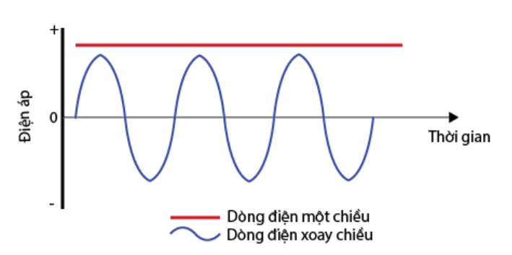
* ***Example of an Analog signal representing direct current and rotation***

**Digital Signal:**

* - Digital signals represent information in discrete form, encoded into numeric values and transmitted in fixed units.
* - Digital signals are represented as bits (0 and 1), which are the result of digitizing analog signals. Digital devices use digital signals to transmit, store and process data.
* 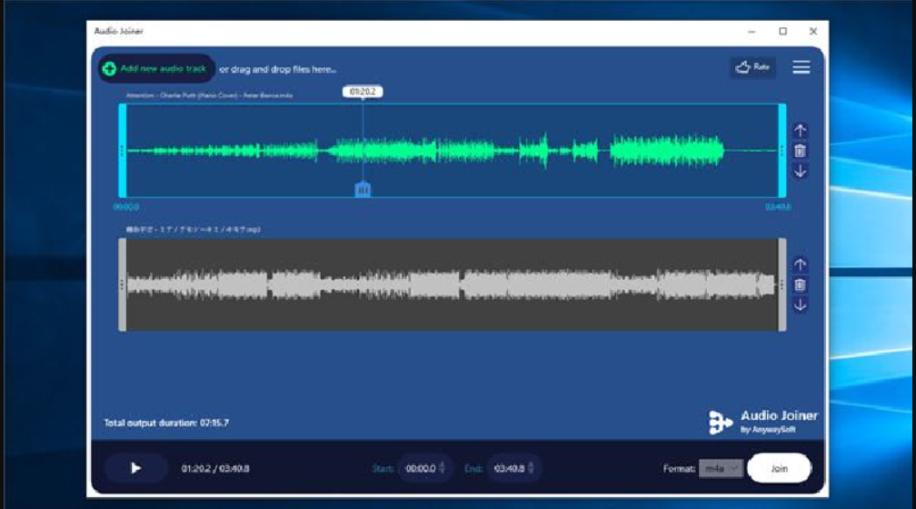
* ***Example Of Audio Histogram Of An Audio File***
* **Analog-to-Digital Conversion (ADC) process:**  
  This is the process of converting analog signals into digital form so that they can be processed, stored and transmitted more easily. This process includes two main steps: sampling and quantization.
* Sampling:
* **Definition:** The first step in the ADC process is sampling, in which the analog signal is divided into samples taken at fixed time intervals.
* **Sampling Rate:** The sampling frequency determines the number of sampling times performed per unit of time, usually measured in Hz. For audio, such as CD audio, the sampling frequency is 44.1 kHz (44,100 samples per second).
* **Shannon-Nyquist theorem:** According to this theorem, to reconstruct an analog signal into a digital signal without loss of information, the sampling frequency needs to be at least twice the highest frequency of the analog signal.
* **Quantization**:
* **Definition:** After sampling, analog samples will be converted into digital values. This process is called quantization, in which the value of each sample is assigned a specific numerical value.
* **Bit Depth:** Bit depth determines the precision of each sample. This is related to the number of bits used to represent each sample. For example, CD audio uses a bit depth of 16 bits per sample, allowing about 65,536 different values (2^16).
* **Level of detail and noise:** The higher the bit depth, the closer the digital signal is to the original analog signal. However, using fewer bits can lead to information loss (noise) and vice versa.

The ADC process is important in converting signals from the analog world into digital form so that they can be processed in digital devices such as computers, cell phones, music players, and many other technology applications.

1. **Digital audio format and encoding:**

**Audio File Format**: There are many audio file formats such as MP3, WAV, FLAC, and AAC. Each format has its own characteristics in quality and file size.  
**Audio encoding**: Encoding algorithms such as MP3, AAC, or OGG help compress audio data to reduce storage capacity and optimize transmission over the network.

1. **Digital audio processing and reproduction:**

**8.1 Digital Signal Processing (DSP)**:

This is an important field in technology and computer science, involving the processing and analysis of digital signals to extract information, improve quality, or create audio-visual effects.  
**Basic aspects of DSP:**

* **Signal Filtering**: Apply filters (pass filters, mode filters, noise filters) to remove or minimize noise and unwanted signals, or to extract specific signal components.
* **Signal Transformations**: Transforms signals from one spatial domain to another to analyze or obtain necessary information. For example, Fourier transform to convert a signal from the time domain to the frequency domain.
* **Image and Audio Processing**: DSP is widely used in image processing (such as in digital cameras, image processing technology) and audio processing (improving sound quality, reducing noise, creating sound effect).
* **Encoding and Decoding**: DSP is often used in the process of encoding and decoding digital signals, such as MP3 encoding, video encoding, and other data compression standards.
* **Signal Analysis**: DSP helps analyze digital signals to find useful information, such as recognizing patterns, determining signal characteristics, or predicting trends.
* **Applications in Communications and Networking**: DSP plays an important role in signal processing in communication systems, network signal processing, improving communication quality, and increasing data transmission speed.

**Tools and methods:**

* **DSP software and hardware**: Digital processors, microcontrollers, and specialized DSP software are used to perform complex mathematical operations on signals.
* **DSP Algorithm**: Includes popular signal processing algorithms such as FFT (Fast Fourier Transform), FIR (Finite Impulse Response), IIR (Infinite Impulse Response), and many others.

**8.2 Digital-to-Analog Conversion (DAC)**:

This is the process of converting digital signals into analog signals so that sound, images, or other analog signals can be reproduced and output. This is commonly implemented in many electronic devices from music players, speakers, to communication devices.

**Main steps in the DAC process:**

1. **Digital Data Input**: Digital data is input to the DAC from a source such as digital audio files, video data, or from any other digital data storage device.
2. **Data Filtering and Formatting**: In some cases, data may need to be filtered or formatted to prepare for conversion.
3. **Conversion Process**:
   1. **Digital signals to analog signals**: Digital signals, usually a string of bits, are converted into corresponding analog values. Each numerical value represents a corresponding voltage or current level in the analog signal.
   2. **Conversion method**: Most DAC devices use converters such as R-2R ladder, sigma-delta, or other types to convert digital data to analog signals.
4. **Analog Outpu**t: After the conversion process is complete, an analog signal is created, preparing it for output through speakers, headphones, or any other device that requires a signal. analog signal.

**Characteristics and Applications of DAC:**

* **Accuracy and resolution**: The precision of a DAC affects the quality of the sound or image reproduced.
* **Use in industry and consumer electronics**: DACs are widely used in electronic devices such as phones, music players, speakers, TVs, and other communication devices.
* **Digital audio and video**: In digital audio and video decoding devices, DAC converts data from digital formats (such as MP3 files, video) into analog signals to output to speakers or displays.

The DAC process plays an important role in reproducing analog signals from digital data, making it possible for us to experience high-quality sound and images from various electronic devices.

1. **Applications of digital audio:**

* **Streaming Audio and Media**: Digital audio technology allows for convenient and efficient streaming of music and video over the internet.
* **Media and Communication Applications**: Digital audio is used in communication applications such as video calling, online conferencing, and other communication applications.
* **Application in other online applications such as**: games, notifications, recording, …

The transition from analog audio to digital audio has created great convenience in storing, transmitting and processing sound, opening up many opportunities for developing audio applications in many different fields.

**Chapter 4: KIT DE2 70 Cyclone II and Wolfson WM8731**

**4.1 FPGA technology:**

- Field-programmable gate array (FPGA) is a type of large integrated circuit that uses a logic element array structure that can be programmed by the user. The word field here refers to the user's "external" reprogramming ability, independent of the complex production line of the semiconductor factory. FPGA microchip is made up of parts:

* Basic programmable logic blocks (logic blocks).
* Programmable interconnect circuit system,
* I/O Pads (IO Pads).
* Other pre-designed elements such as DSP slice, RAM, ROM, processor core, etc.

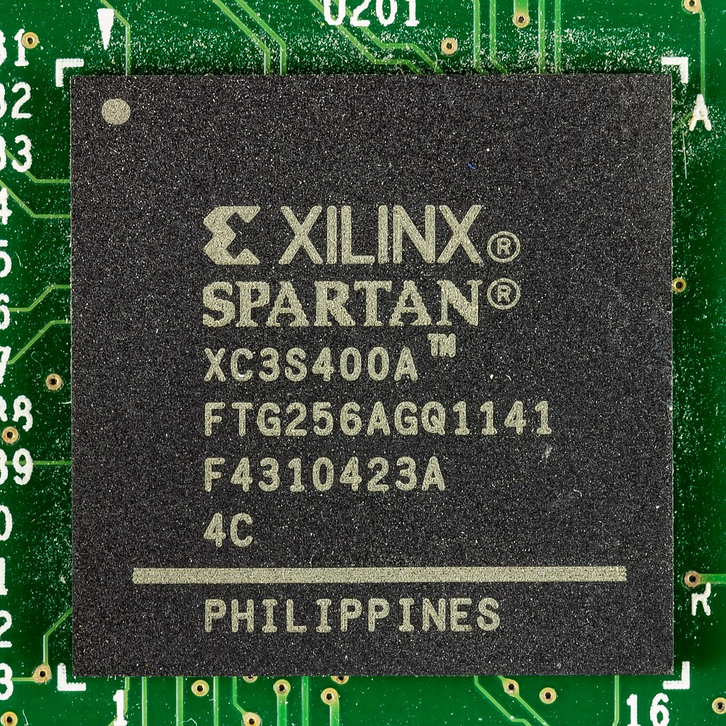

- Design or programming for FPGA is done mainly using HDL hardware description languages such as VHDL, Verilog. Large FPGA manufacturers such as Xilinx and Altera often provide software packages and auxiliary equipment for the design process. There are also a number of third-party companies that provide such software packages such as Synopsys, Synplify, etc. These software packages are capable of performing all steps of the entire standard IC design process with input as design code on HDL (also known as RTL code).

***The overall structure of an FPGA is illustrated in the following figure:***

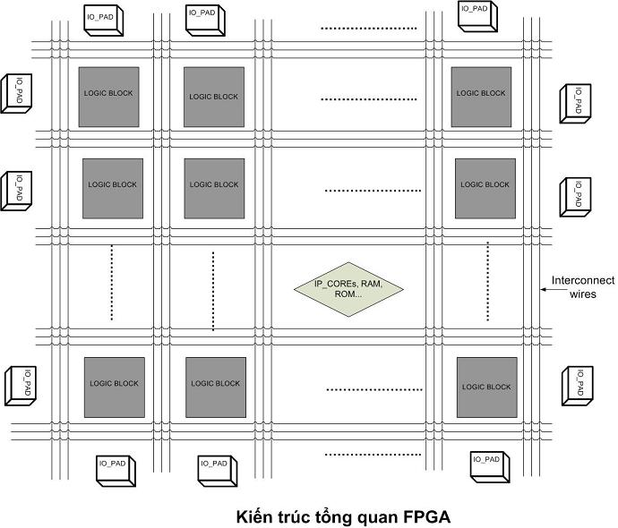

In there:

* **Logic Block:** The main element of FPGA is logic blocks. The logic block is composed of a LUT and a flip-flop synchronous memory element.
* **Link circuit system:** The link network in FPGA is made up of horizontal and vertical connection lines. Depending on the type of FPGA, the connection lines are divided into different groups.
* **Built-in elements:** In addition to logic blocks, depending on different types of FPGA, there are different built-in elements, for example to design SoC applications, Xilinx's Virtex 4.5 line contains cores. PowerPC processing, or in Atmel FPSLIC integrated AVR core...
* **Block RAM:** In addition, Xilinx FPGAs also have block RAM, which can be imagined as a small memory located inside the FPGA. These RAM blocks are small (about a few dozen kilograms of bits to several million bits depending on the type of FPGA), but can be used to create a small memory such as ROM or FIFO.

**4.2 Some FPGA KITS:**

Some popular FPGA kits today:

**1. DE2 Development and Education Board - Terasic (Altera/Intel FPGA)**

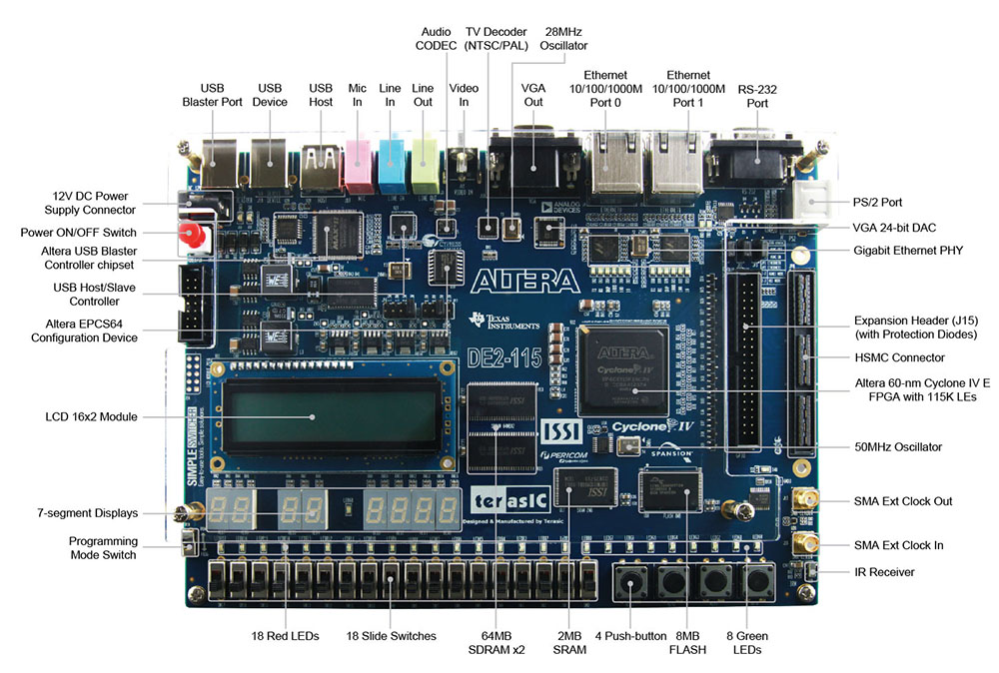

* Manufacturer: Terasic
* FPGA: Altera Cyclone II
* Integrated: GPIO, VGA, Ethernet port, USB port, acceleration sensor, light sensor, audio port, RS-232 port.

**2. Basys 3 Artix-7 FPGA Trainer Board - Digilent (Xilinx FPGA)**

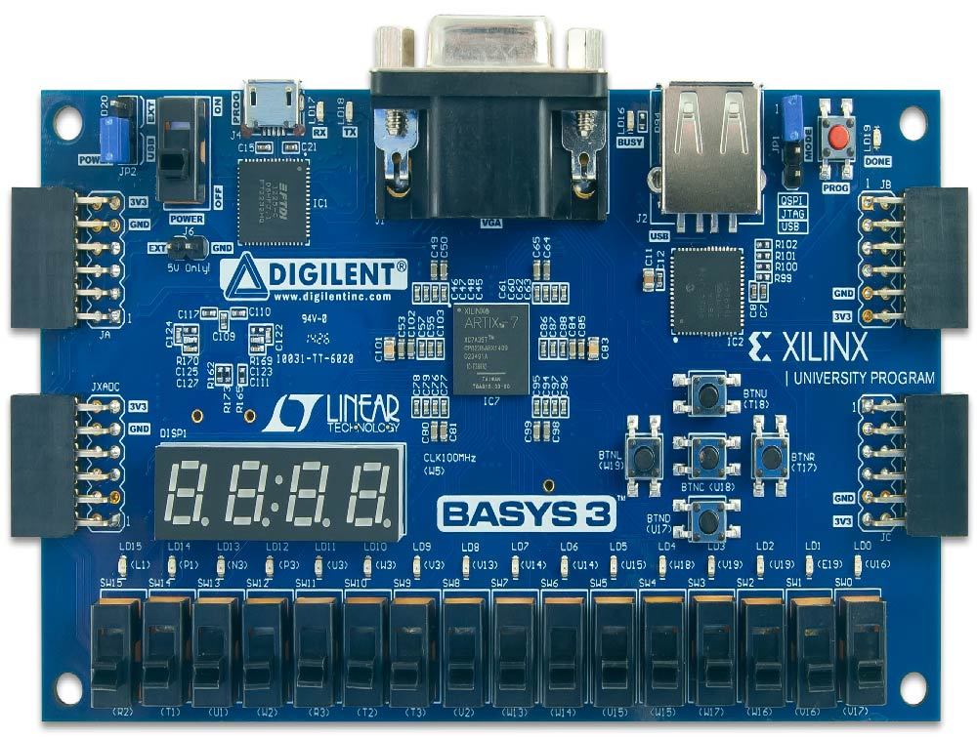

* Manufacturer: Digilent
* FPGA: Xilinx Artix-7 FPGA
* Integrated: GPIO, VGA, USB-UART, Ethernet port, acceleration sensor, light sensor.

**3. ULX3S FPGA Development Board - Lattice FPGA**

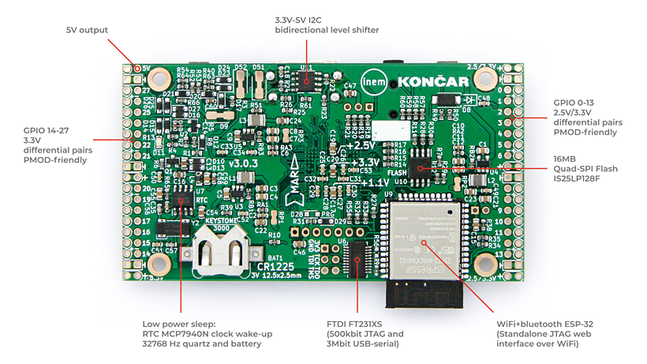

* Manufacturer: Radiona.org
* FPGA: Lattice ECP5
* Integrated: HDMI, USB, MicroSD, Ethernet port, GPIO, VGA port

**4.3 DE2-70 Kit**

**4.3.1: Overview**

- Kit Altera DE2-70 Board is a popular product from Terasic, designed to support learning and project development using Altera FPGAs. Use Altera (Intel) FPGA - Usually Cyclone II series or other FPGA series depending on the specific version.

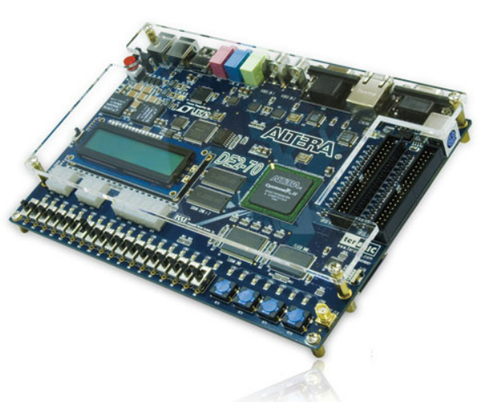

**Features:**

* **GPIO (General Purpose I/O)**: Provides a number of I/O ports to connect to peripheral devices.
* **Memory**: Usually has integrated RAM (SRAM or SDRAM) for data storage.
* **Communication**: Communication ports such as UART port, USB port, Ethernet port, and RS-232 port.
* **Sensors**: Some versions have built-in accelerometers, light sensors, and other sensors.
* **Display**: VGA port or HDMI port to display data.

**Support Software:**

* Supported by Altera's Quartus Prime software for FPGA design and programming.
* Can support programming languages such as Verilog and VHDL

**Application:**

* Used in education to teach and learn logic and microcontroller design.
* Suitable for embedded and digital signal processing projects.

**4.3.2 Diagram**

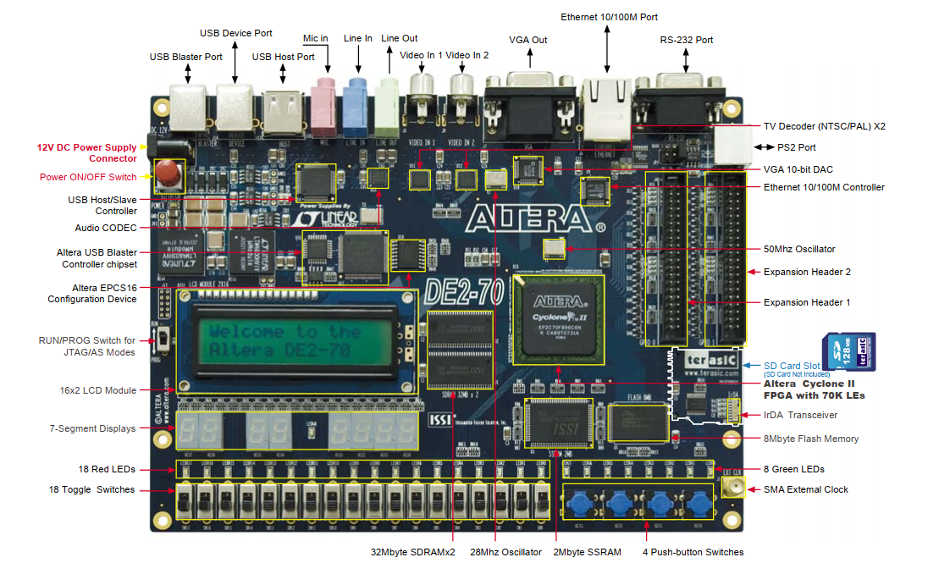

**The following hardware is provided on the DE2-70 board:**

* Altera Cyclone® II 2C70 FPGA device
* Altera Serial Configuration device - EPCS16
* USB Blaster (on board) for programming and user API control
* 2-Mbyte SSRAM
* Two 32Mbyte SDRAM
* 8-Mbyte Flash memory
* SD Card socket
* 4 pushbutton switches
* 18 toggle switches
* 18 red user LEDs
* 9 green user LEDs
  + 50-MHz oscillator and 28.63-MHz oscillator for clock sources
  + 24-bit CD-quality audio CODEC with line-in, line-out, and microphone-in jacks
  + VGA DAC (10-bit high-speed triple DACs) with VGA-out connector
  + 2 TV Decoder (NTSC/PAL/SECAM) and TV-in connector
  + 10/100 Ethernet Controller with a connector
  + USB Host/Slave Controller with USB type A and type B connectors
  + RS-232 transceiver and 9-pin connector
  + PS/2 mouse/keyboard connector
  + IrDA transceiver
  + 1 SMA connector
  + Two 40-pin Expansion Headers with diode protection

**Block Diagram of the DE2-70 Board:**

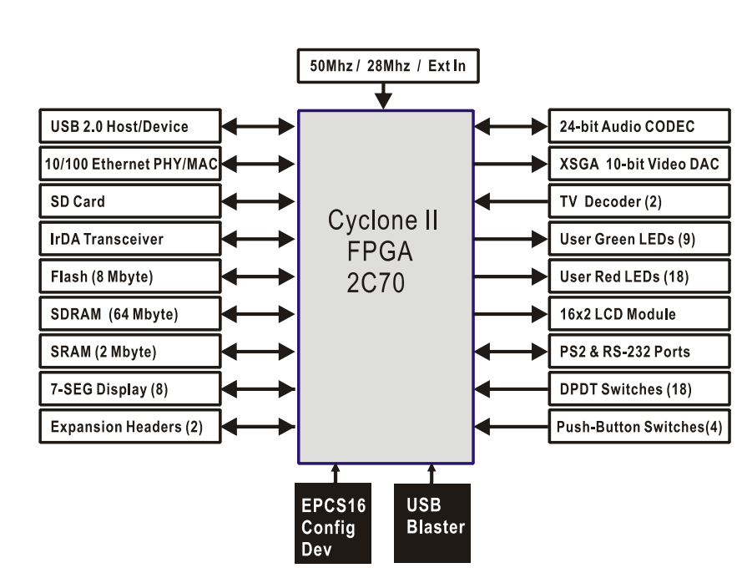

**4.4 Wolfson WM8731 audio chip:**

The WM8731 is a low power stereo CODEC with an integrated headphone driver. It offers the user the unique ability to independently program the ADC and DAC sample rates from a single clock source. The WM8731 is designed specifically for portable MP3 audio and speech players and recorders.

Stereo 24-bit multi-bit sigma delta ADCs and DACs are used with oversampling digital interpolation and decimation filters. Digital audio input word lengths from 16-32 bits and sampling rates from 8kHz to 96kHz are supported.

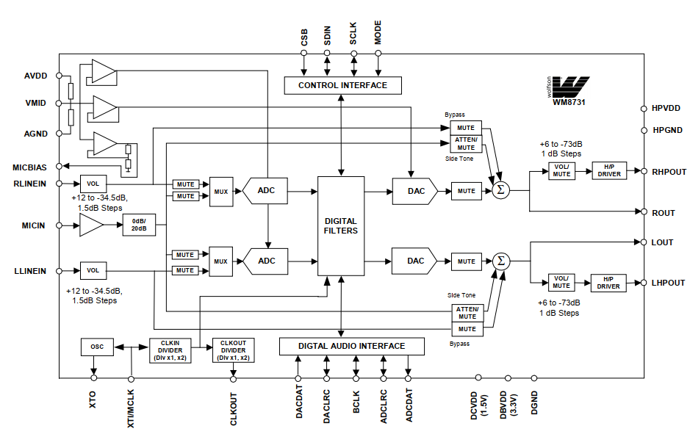

**Pin configuration:**

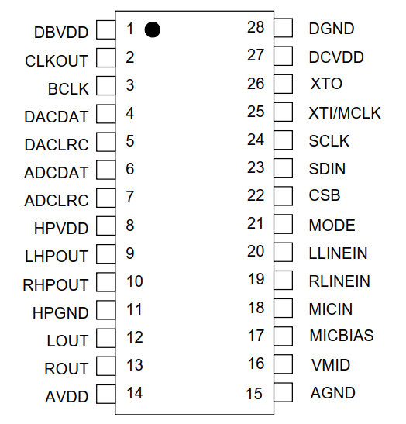

***Pin Configuration***

**Line input:**

The WM8731 provides Left and Right channel line inputs (RLINEIN and LLINEIN). The inputs are high impedance and low capacitance, thus ideally suited to receiving line level signals from external hi-fi or audio equipment.

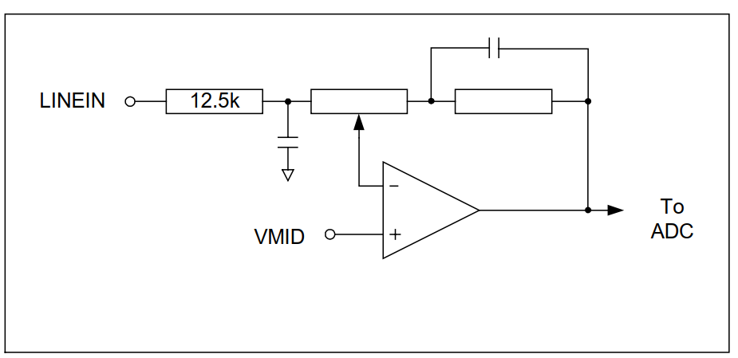

**Line Input Software Control:**

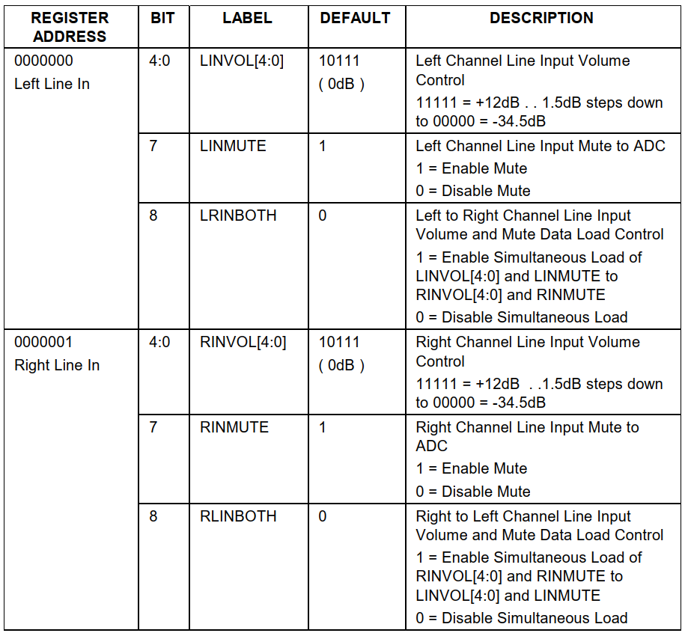

**ADC:**

The WM8731 uses a multi-bit oversampled sigma-delta ADC.

**ADC Software Control:**

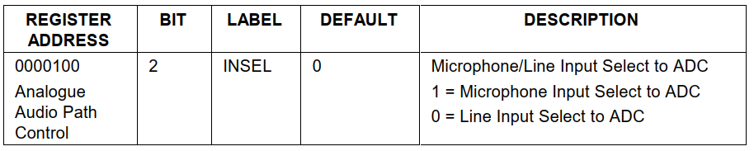

**ADC Filters:**

The ADC filters perform true 24 bit signal processing to convert the raw multi-bit oversampled data from the ADC to the correct sampling frequency to be output on the digital audio interface.

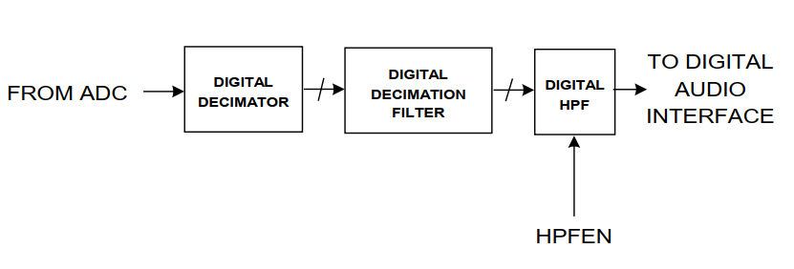

**DAC Filters:**

The DAC filters perform true 24 bit signal processing to convert the incoming digital audio data from the digital audio interface at the specified sample rate to multi-bit oversampled data for processing by the analogue DAC.

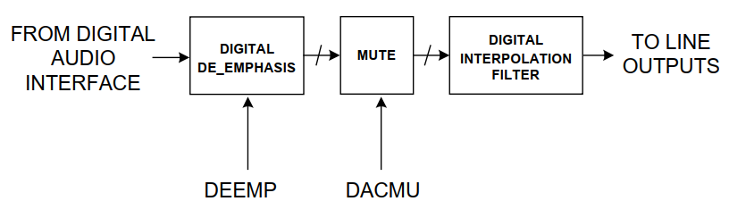

**The DAC Software Control:**

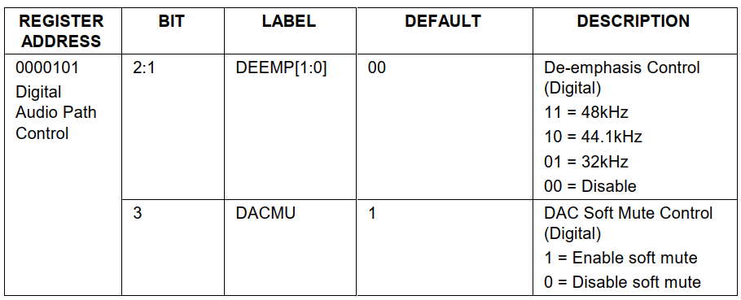

**DAC:**

The WM8731 employs a multi-bit sigma delta oversampling digital to analogue converter.

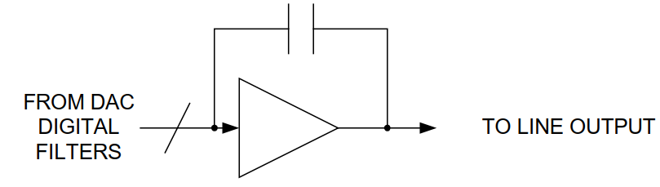

The DAC converts the multi-level digital audio data stream from the DAC digital filters into high quality analogue audio.

**Line Output:**

The WM8731 provides two low impedance line outputs **LLINEOUT** and **RLINEOUT**. The line output is used to selectively sum the outputs from the DAC or/and the Line inputs in bypass mode.

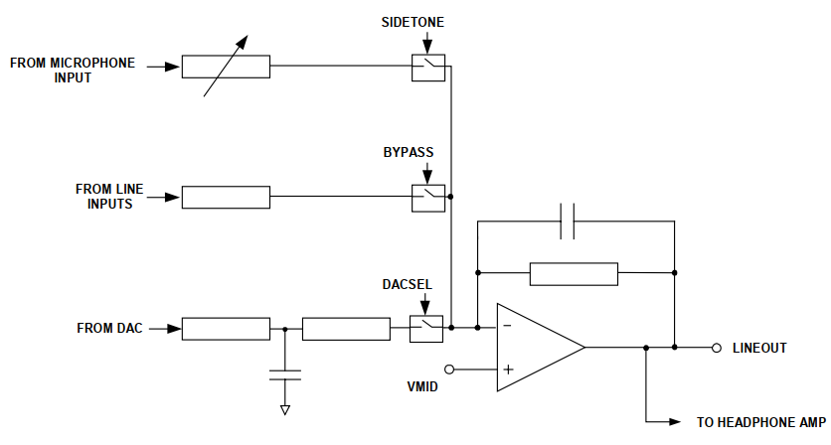

The line output is muted by either muting the DAC (analogue) or Soft Muting (digital) and disabling the BYPASS and SIDETONE paths.

**Line Output Software Control:**

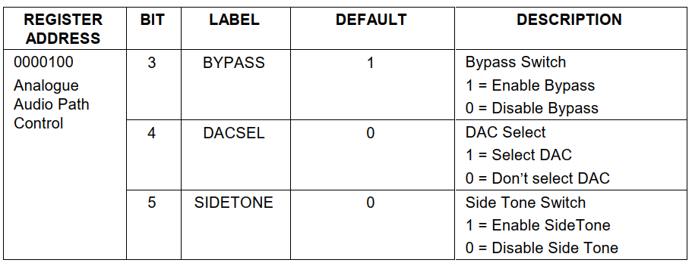

**Bypass Mode:**

The WM8731 includes a bypass mode whereby analogue line inputs are routed directly to the analogue line outputs and headphone outputs.

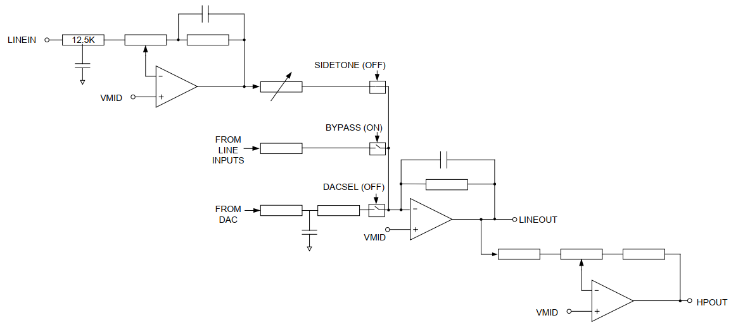

**Bypass Mode Software Control:**

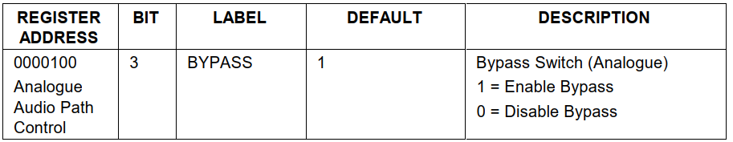

**Sidetone Mode:**

The WM8731 also includes a side tone mode where the microphone input is routed to line and headphone outputs. The side tone mode allows the microphone input to be attenuated to the outputs for telephone and headset applications.

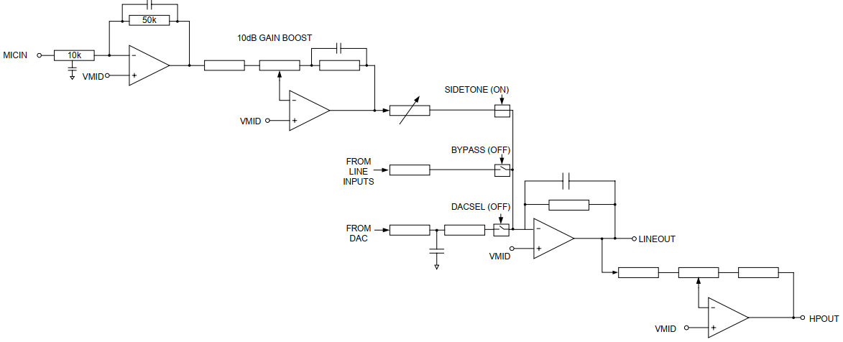

**Sidetone Mode Software Control:**

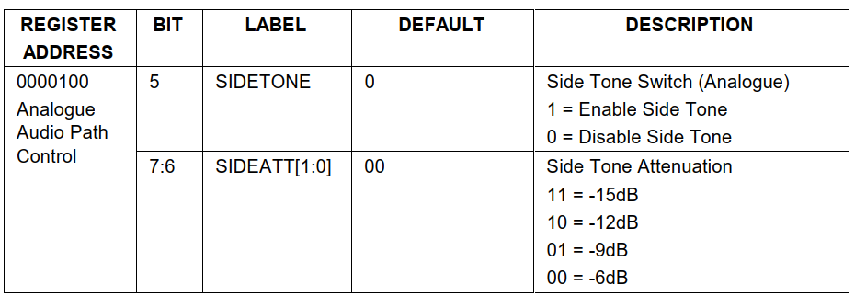

**Digital Audio Interfaces:**

WM8731 may be operated in either one of the 4 offered audio interface modes. These are:

• Right justified

• Left justified

• I2S

• DSP mode

* All four of these modes are MSB first and operate with data 16 to 32 bits.
* The digital audio interface takes the data from the internal ADC digital filter and places it on the ADCDAT output. ADCDAT is the formatted digital audio data stream output from the ADC digital filters with left and right channels multiplexed together. ADCLRC is an alignment clock that controls whether Left or Right channel data is present on the ADCDAT lines. ADCDAT and ADCLRC are synchronous with the BCLK signal with each data bit transition signified by a BCLK high to low transition. BCLK may be an input or an output dependent on whether the device is in master or slave mode.
* The digital audio interface also receives the digital audio data for the internal DAC digital filters on the DACDAT input. DACDAT is the formatted digital audio data stream output to the DAC digital filters
* with left and right channels multiplexed together. DACLRC is an alignment clock that controls whether Left or Right channel data is present on DACDAT. DACDAT and DACLRC are synchronous with the BCLK signal with each data bit transition signified by a BCLK high to low transition. DACDAT is always an input. BCLK and DACLRC are either outputs or inputs depending whether the device is in master or slave mode.
* In this project, we use DSP Mode so we will talk about DSP Mode.

**DSP Mode:**

DSP mode is where the left channel MSB is available on either the 1st or 2nd rising edge of BCLK (selectable by LRP) following a LRC transition high. Right channel data immediately follows left channel data.

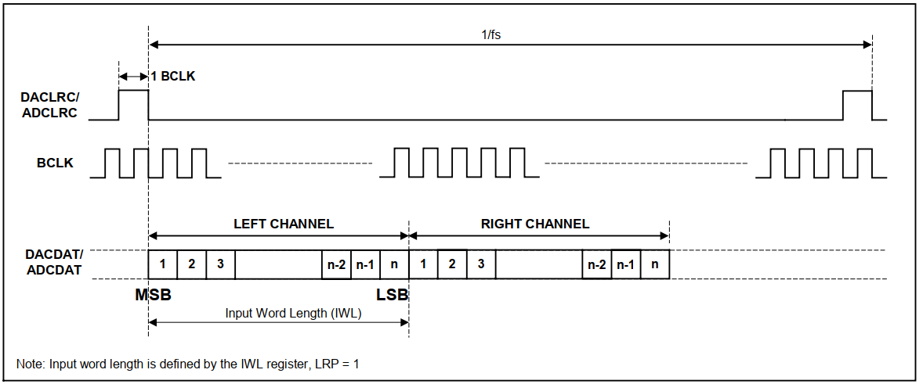

DACLRC and ADCLRC must always change on the falling edge of BCLK. ADCDAT lines are always outputs and DACDAT lines are always inputs. ADCLRC, DACLRC and BCLK can be either outputs or inputs depending on whether the device is configured as a master or slave. If the device is a master then the DACLRC and BCLK signals are outputs that default low. If the device is a slave then the DACLRC and BCLK are inputs.

**Digital Audio Interface Control:**

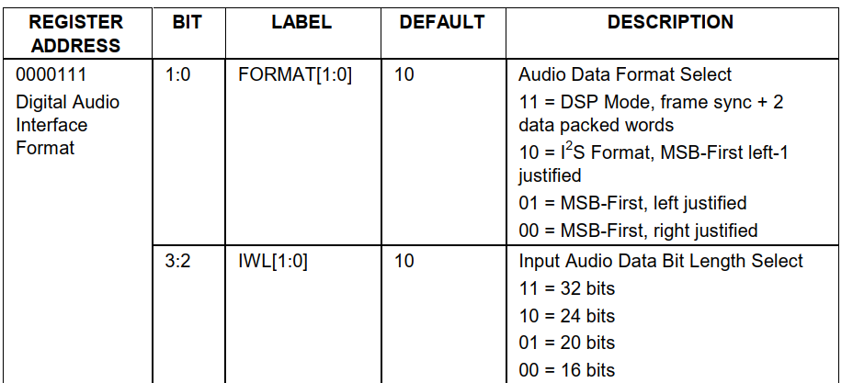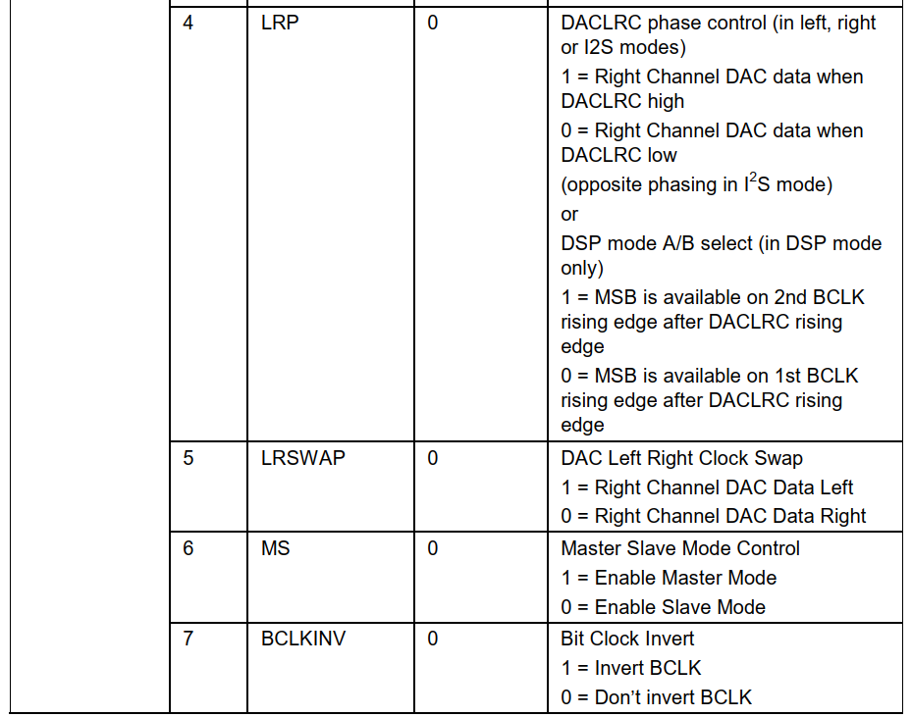

**Master and Slave Mode Operation:**

The WM8731 can be configured as either a master or slave mode device. As a master mode device the WM8731 controls sequencing of the data and clocks on the digital audio interface. As a slave device the WM8731 responds with data to the clocks it receives over the digital audio interface.

**Master/Slave Mode Software Control:**

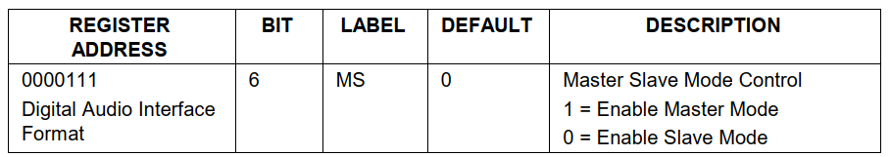

As a master mode device the **WM8731** controls the sequencing of data transfer (ADCDAT, DACDAT) and output of clocks (BCLK, ADCLRC, DACLRC) over the digital audio interface.

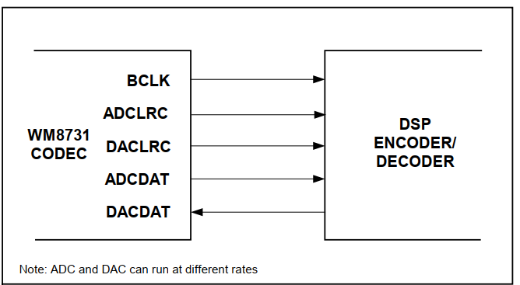

As a slave device the WM8731 sequences the data transfer (ADCDAT, DACDAT) over the digital audio interface in response to the external applied clocks (BCLK, ADCLRC, DACLRC).

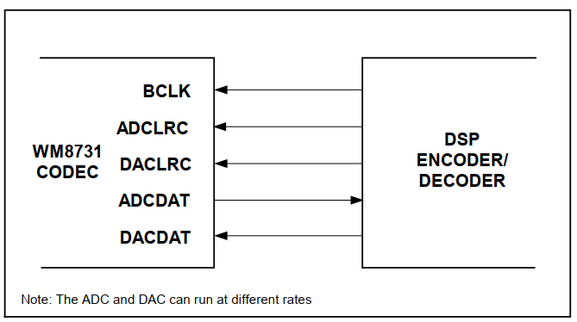

**Activating DSP and Digital Audio Interface:**

Once the Audio Interface and the Sampling Control has been programmed it is activated by setting the ACTIVE bit under Software Control.

**Activating DSP and Digital Audio Interface Software Control:**

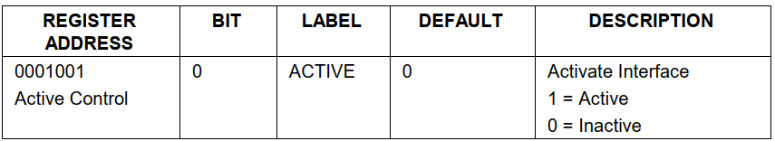

**I2C (2-wire) Serial Control Mode:**

The WM8731 supports a 2-wire MPU serial interface. The device operates as a slave device only.

**I2C (2-wire) Serial Interface:**

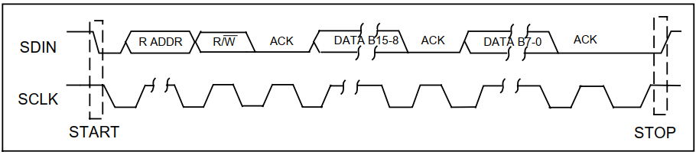

**Note:**

1. B[15:9] are Control Address Bits

2. B[8:0] are Control Data Bits

**I2C(2-wire) MPU Interface Address Selection:**

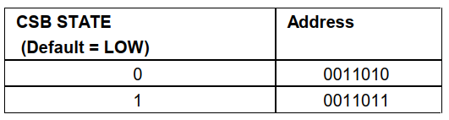

**Power Down Modes*:***

The WM8731 contains power conservation modes in which various circuit blocks may be safely powered down in order to conserve power. This is software programmable as shown in the table below.

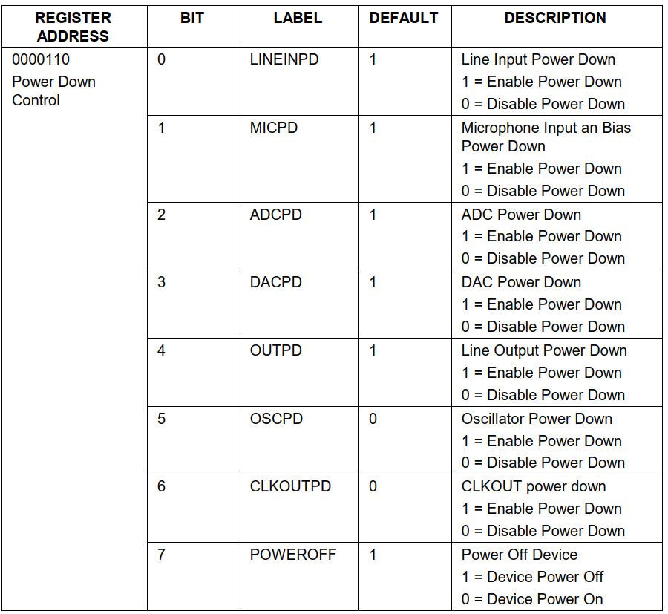

**Register Map:**

There are 11 registers with 16 bits per register (7 bit address + 9 bits of data).These can be controlled using a 2-wire MPU interface.

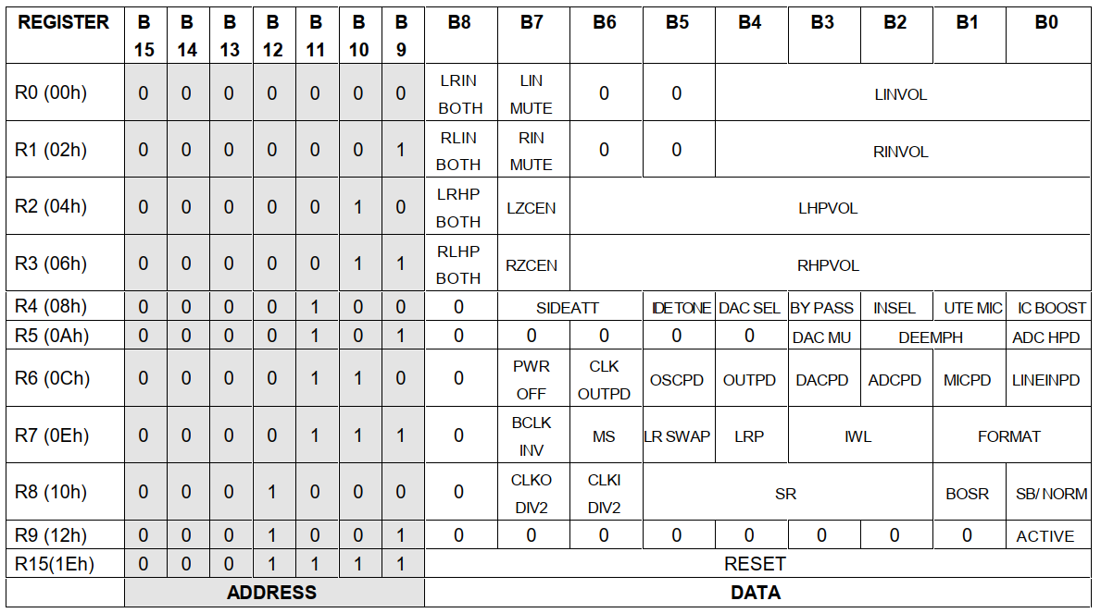

**Register Software Control:**

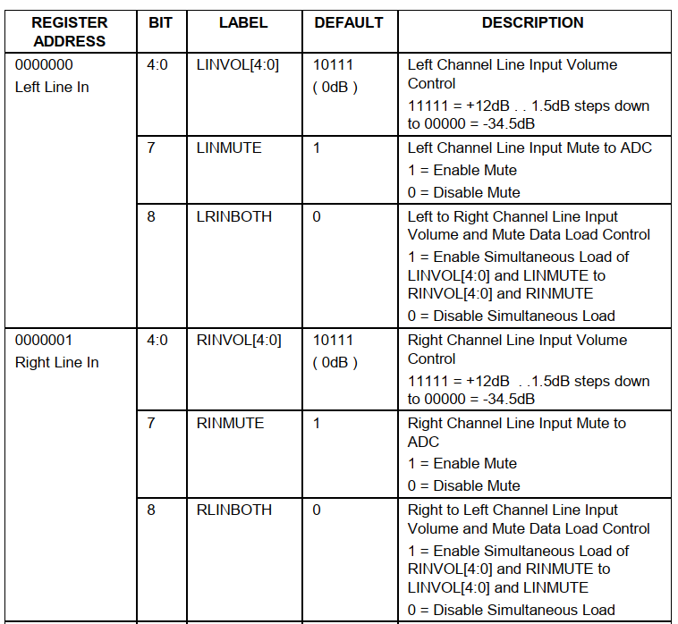

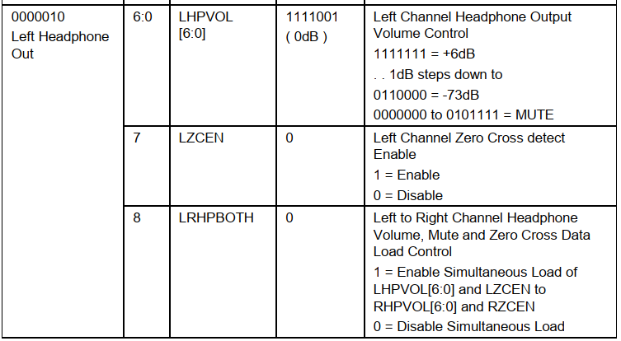

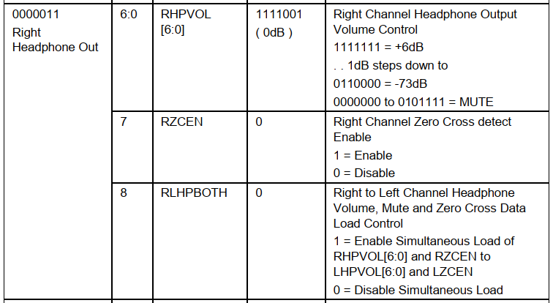

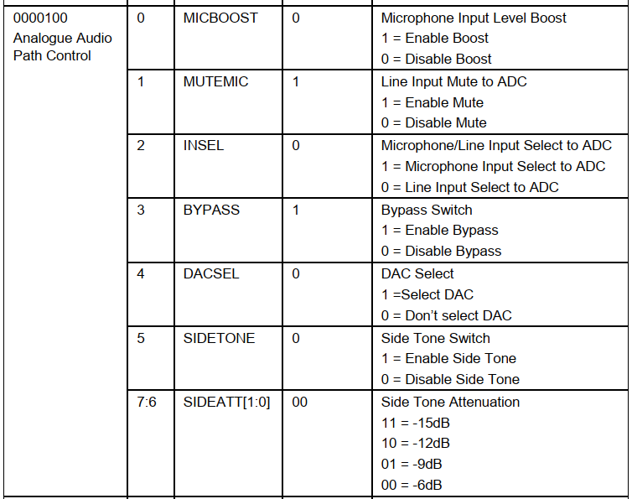

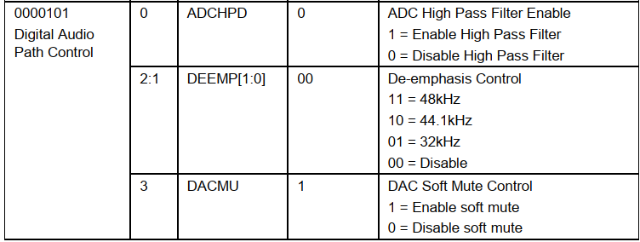

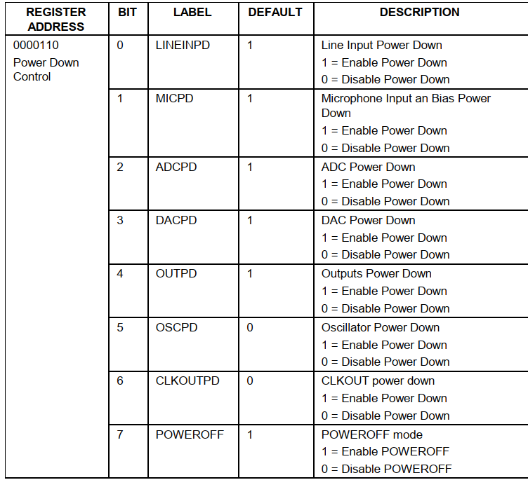

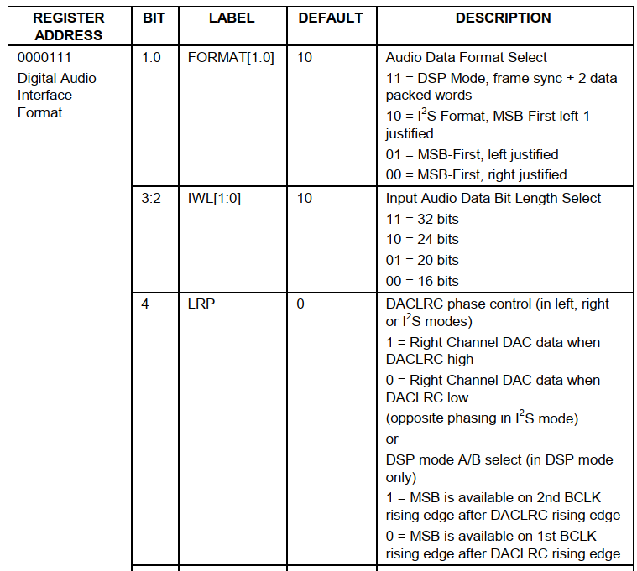

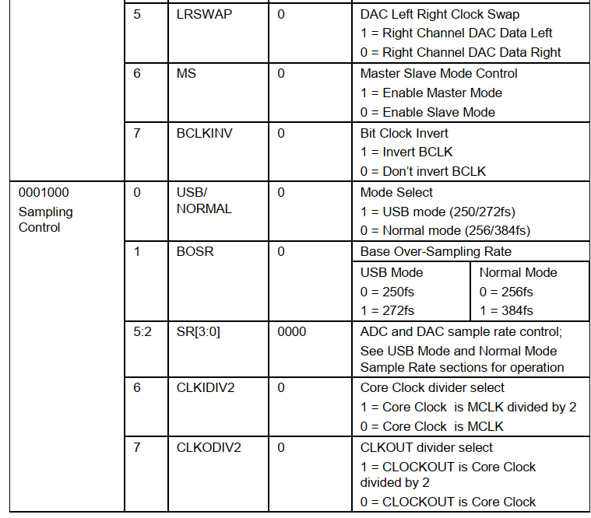

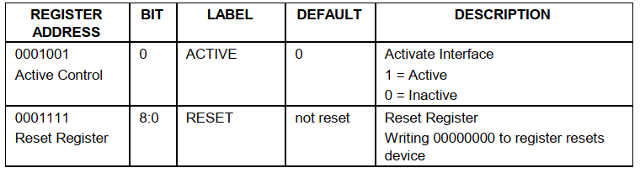

**Chapter 5: Build System**

**5.1 Hardware for audio processing system:**

**5.1.1 Terasic - ALTERA DE2 - 70 BOARD:**

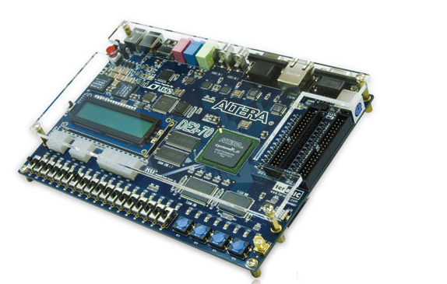

***DE2 - 70***

**Specification Table**

* USB Blaster (on board) for programming and user API control; both JTAG and Active Serial (AS) programming modes are supported
* 2-Mbyte SSRAM
* Two 32-Mbyte SDRAM
* 8-Mbyte Flash memory
* SD Card socket
* 4 pushbutton switches
* 18 toggle switches
* 18 red user LEDs
* 9 green user LEDs
* 50-Mhz oscillator and 28.63-Mhz oscillator for clock sources
* 24-bit CD-quality audio CODEC with line-in, line-out, and microphone-in jacks
* VGA DAC (10-bit high-speed triple DACs) with VGA-out connector
* 2 TV Decoder (NTSC/PAL) and TV-in connector
* 10/100 Ethernet Controller with a connector
* USB Host/Slave Controller with USB type A and type B connectors
* RS-232 transceiver and 9-pin connector
* PS/2 mouse/keyboard connector
* IrDA transceiver
* 1 SMA connector
* Two 40-pin Expansion Headers with diode protection

**5.1.2 Jack 3.5 mm to 3.5 mm:**

We use this jack to take audio signals from the computer and put them into the kit.

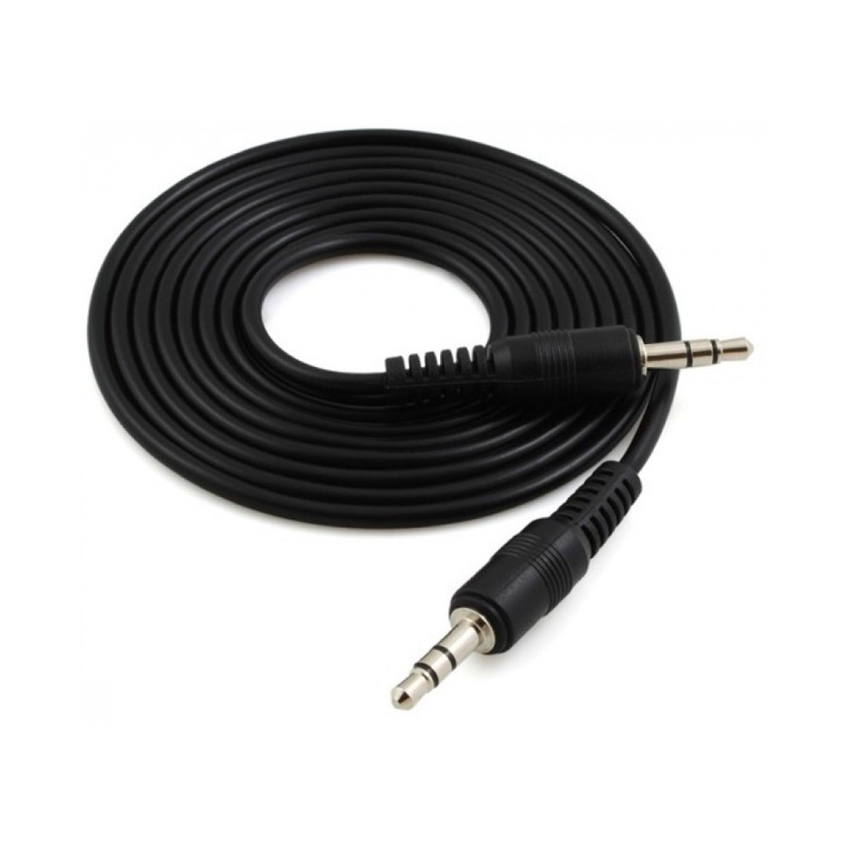

***Jack 3.5mm to 3mm***

**5.1.3 3.5 mm speaker:**

Sound processing requires an output to be observed so we will choose external speakers to use for that.

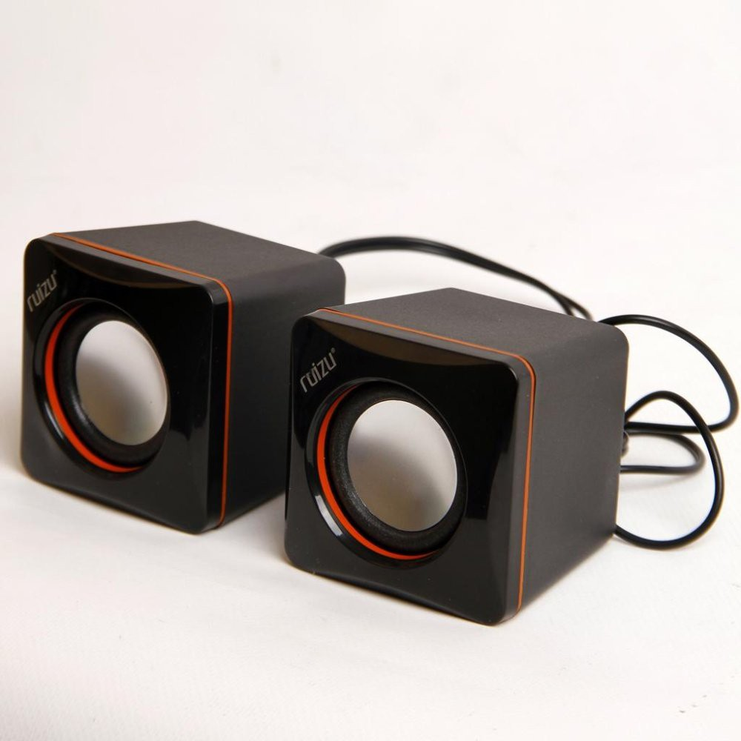

***Mini Multimedia Speaker 2.0***

**5.2 System Hardware Design:**

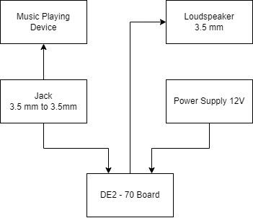

***Block Diagram Of System***

**5.3 System software design:**

**5.3.1 Overview:**

With the **Wolfson WM8731** audio processing chip built into the **DE2** board, we will use the **FPGA** to control it via the I2C protocol. After controlling it, we will design two more modules ADC and DAC to handle the input and output audio.

**5.3.2 I2C Protocol:**

**5.3.2.1 Block Diagram:**

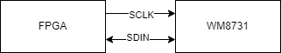

With I2C protocol, the **FPGA** communicates with the **WM8731** as (Master - Slave). That means Chip **WM8731** will comply with the requirements of the **FPGA**.

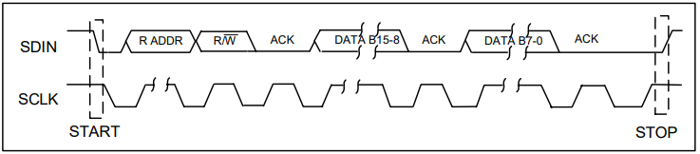

***Wire Serial Interface***

Description:

* To control the WM8731 on the 2-wire bus the master control device must initiate a data transfer by establishing a start condition, defined by a high to low transition on SDIN while SCLK remains high. This indicates that an address and data transfer will follow. All peripherals on the 2-wire bus respond to the start condition and shift in the next eight bits (7-bit address + R/W bit). The transfer is MSB first. The 7-bit address consists of a 6-bit base address + a single programmable bit to select one of two available addresses for this device. If the correct address is received and the R/W bit is ‘0’, indicating a write, then the WM8731/L will respond by pulling SDIN low on the next clock pulse (ACK). The WM8731/L is a write only device and will only respond to the R/W bit indicating a write. If the address is not recognised the device will return to the idle condition and wait for a new start condition and valid address.
* Once the WM8731/L has acknowledged a correct address, the controller will send eight data bits (bits B15-B8). WM8731/L will then acknowledge the sent data by pulling SDIN low for one clock pulse. The controller will then send the remaining eight data bits (bits B7-B0) and the WM8731/L will then acknowledge again by pulling SDIN low.
* A stop condition is defined when there is a low to high transition on SDIN while SCLK is high. If a start or stop condition is detected out of sequence at any point in the data transfer then the device will jump to the idle condition.
* After receiving a complete address and data sequence the WM8731/L returns to the idle state and waits for another start condition. Each write to a register requires the complete sequence of start condition, device address and R/W bit followed by the 16 register address and data bits.

**5.3.2.2 Build I2C Protocol With Verilog:**

With thedescription we will describe the circuit as follows:

* **Code**

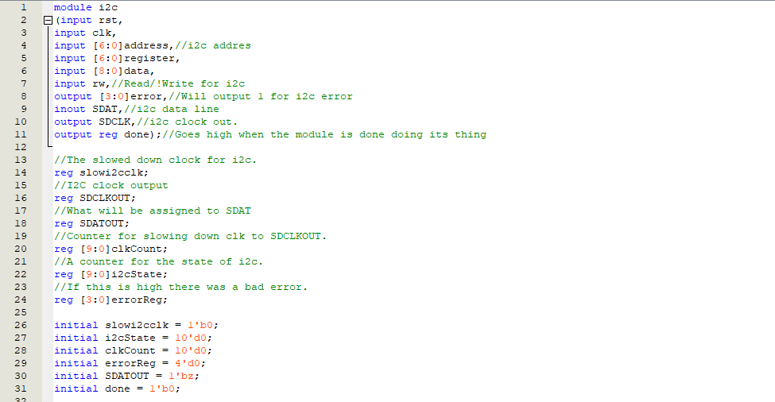

***Signal Declaration***

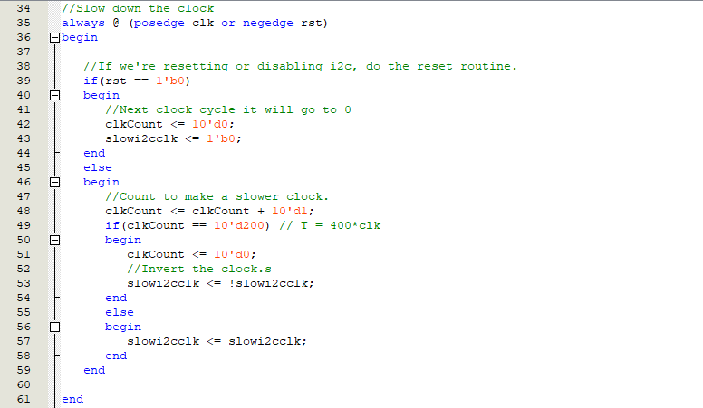

***Create Clock For I2C***

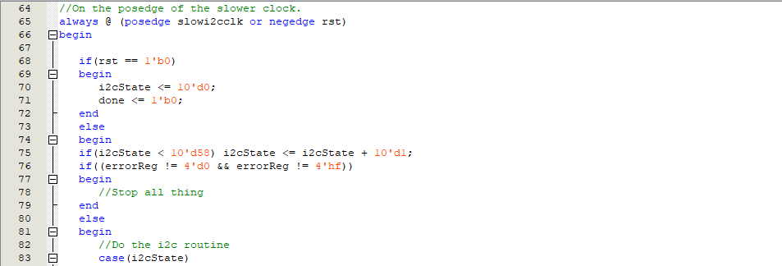

**Create I2C State**

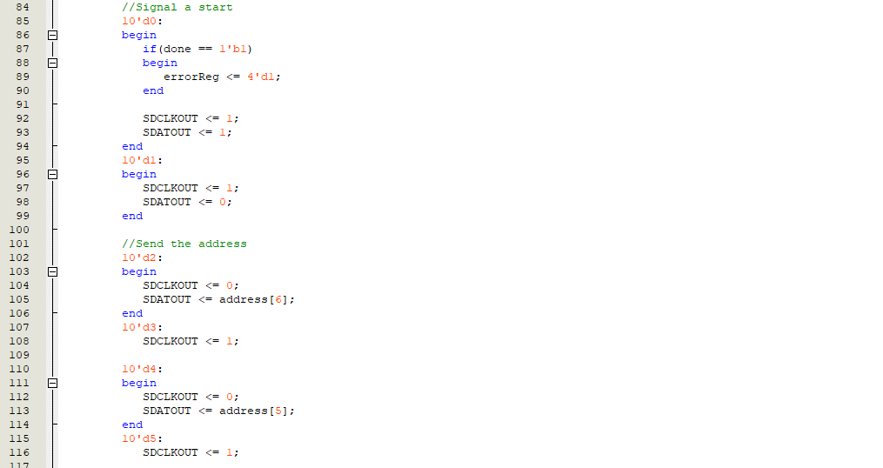

***I2C State Machine***

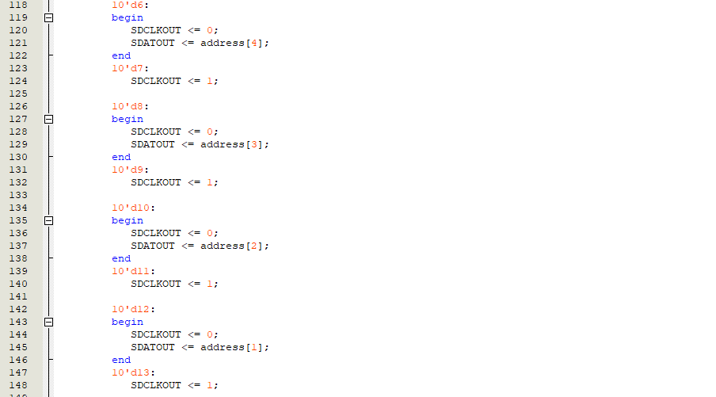

***I2C State Machine***

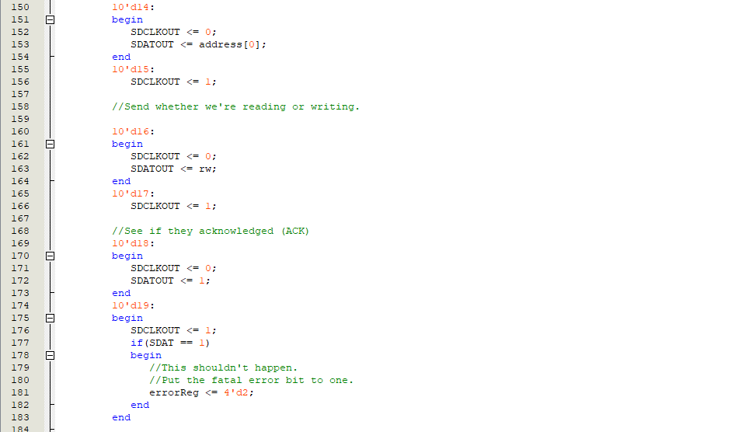

***I2C State Machine***

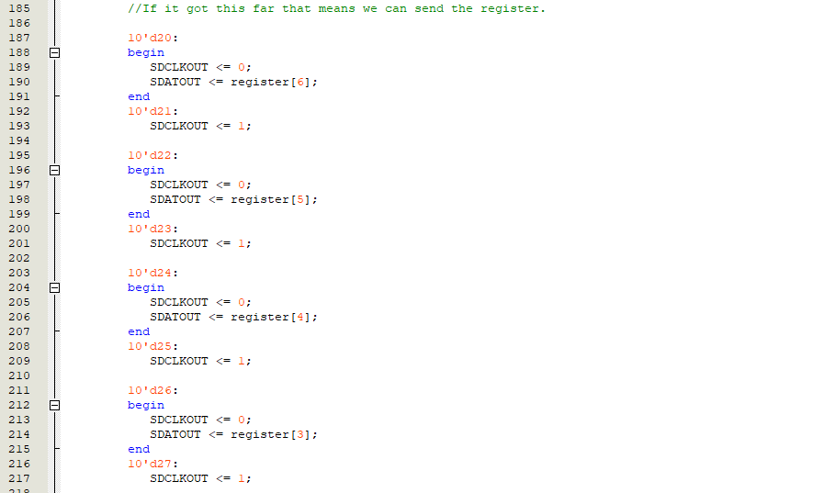

***I2C State Machine***

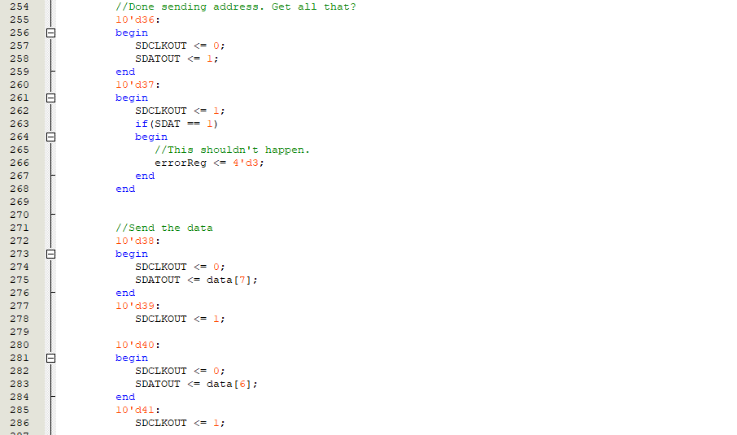

***I2C State Machine***

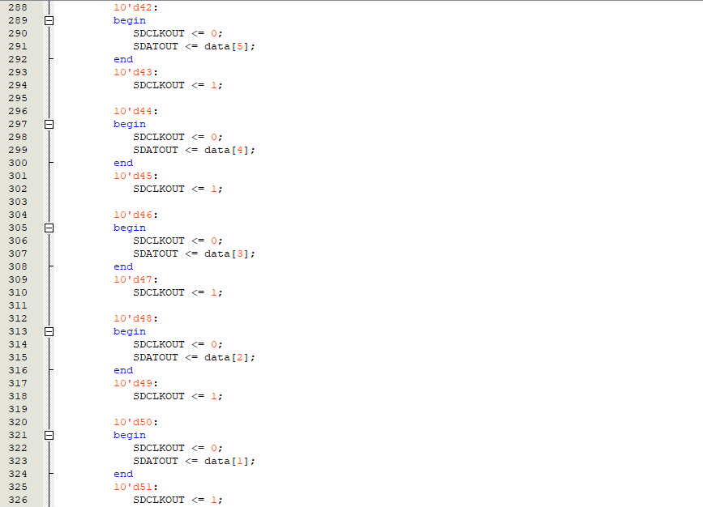

***I2C State Machine***

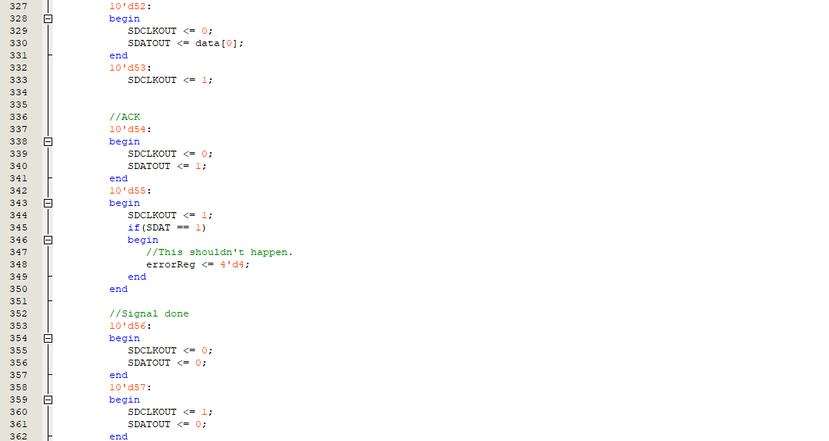

***I2C State Machine***

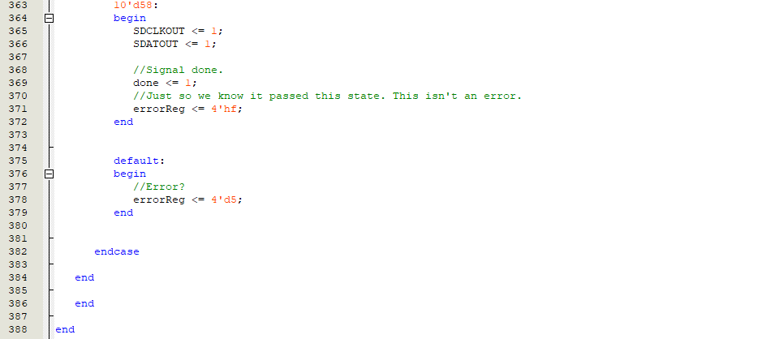

***I2C State Machine***

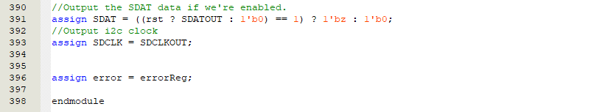

***I2C Result***

**5.3.2.3 RTL Viewer:**

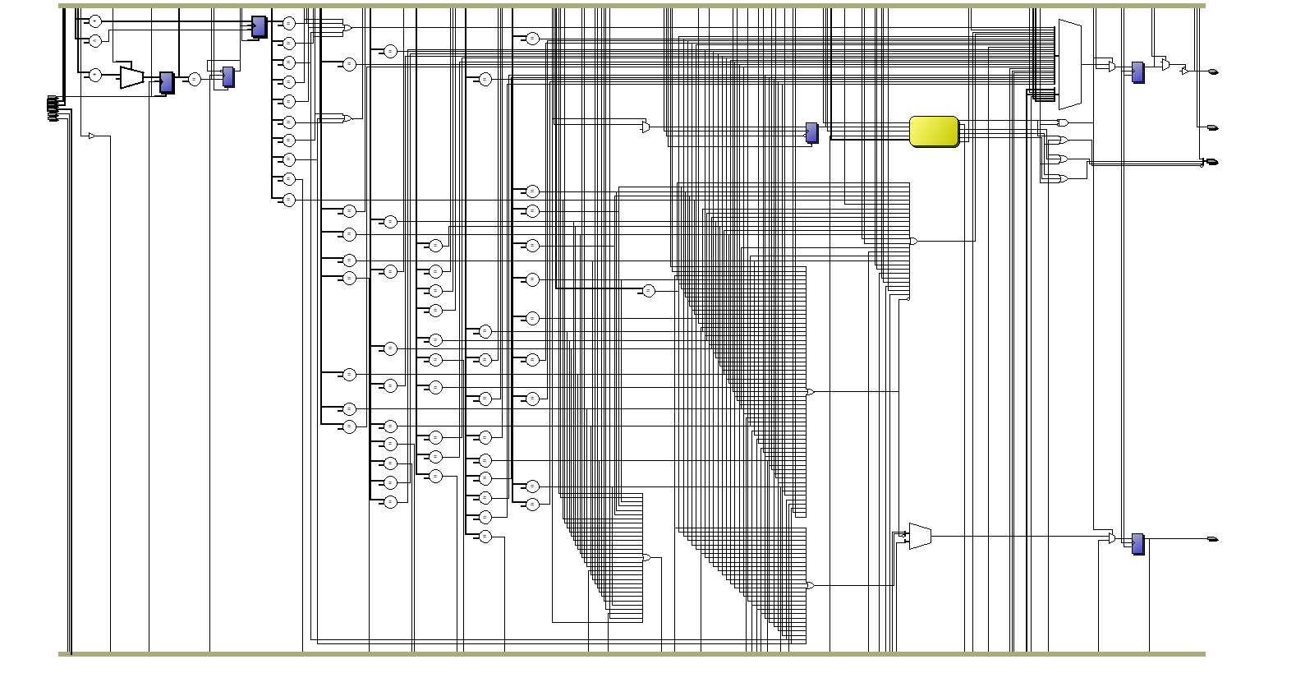

***Circuit Of I2C Protocol***

**5.3.3 Audio Init:**

With Audio Init, we will transmit 8 bits of register address and 9 bits of data for initialization purposes and can freely transmit separate signals to flexibly use the WM8731.

**5.3.3.1 Connection Summary:**

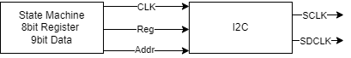

***Connection Diagram***

**5.3.3.2 Build Audio Init:**

* **Code**

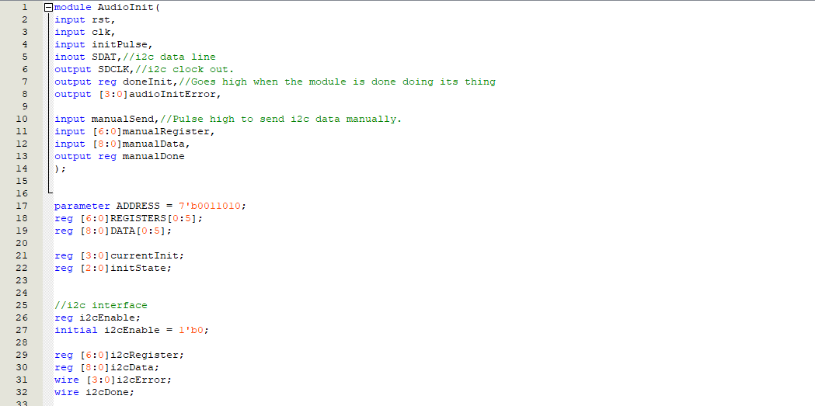

***Signal Declaration***

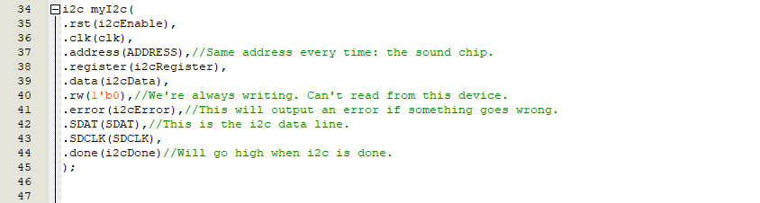

***I2C Module Declaration***

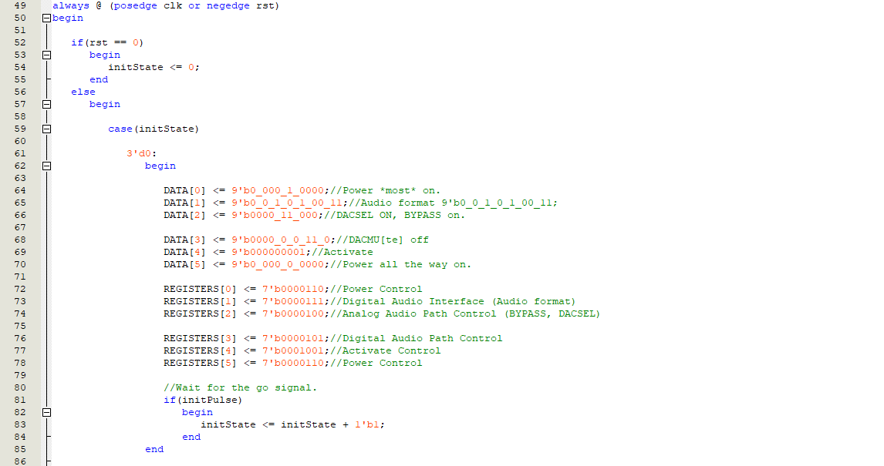

***State Init***

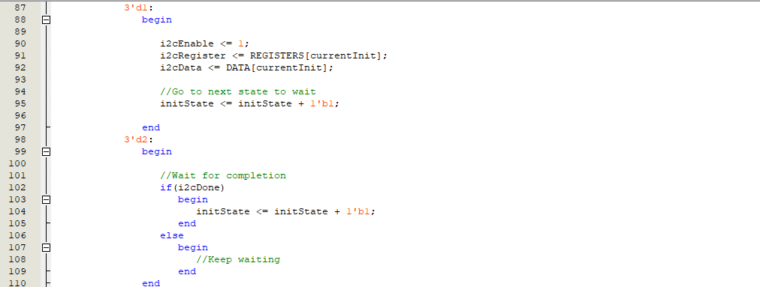

***State Init***

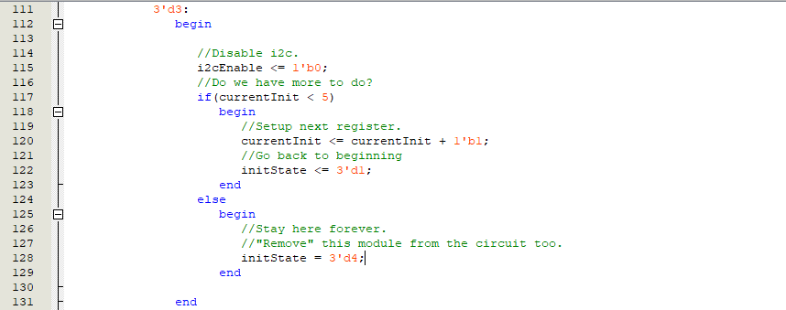

***State Init***

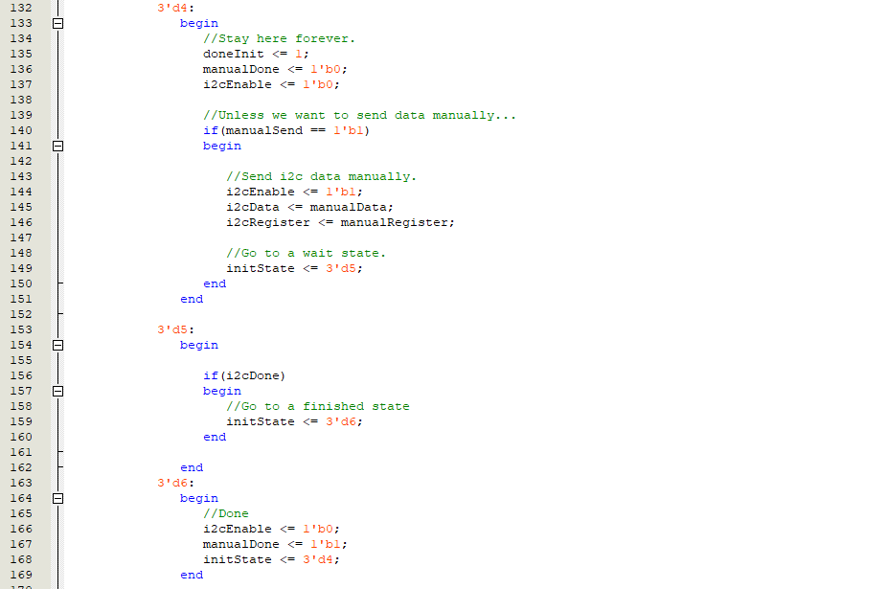

***State Manual Transmission***

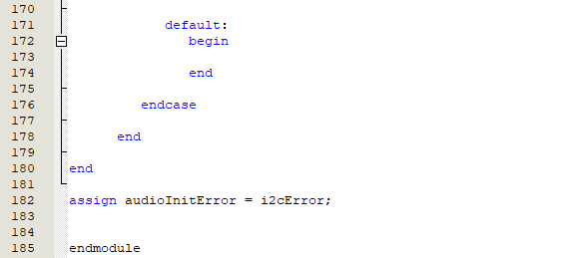

***Default and Error Signal***

**5.3.3.3 RTL Viewer:**

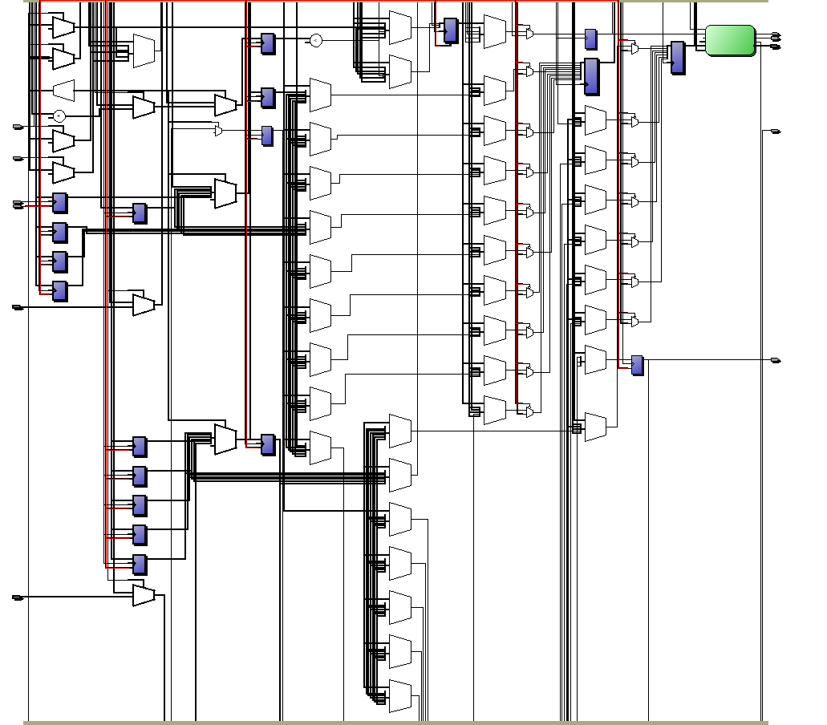

***Circuit Of Audio Init Module***

**5.3.4 Audio ADC:**

Because the FPGA processes the index, when reading the calculated sound from Line In which is an Analog signal, we need to convert this signal into a calculated number. This is where the WM8731 IC comes into play, this IC is capable of converting analog signals into a digital stream that can be used by the FPGA. These patterns do not last long on the FPGA. And the Audio ADC main goal is to get samples from the IC to save and use.

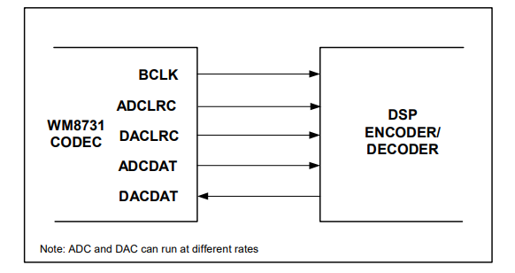

***Master Mode Connection***

**5.3.4.1 Block Diagram:**

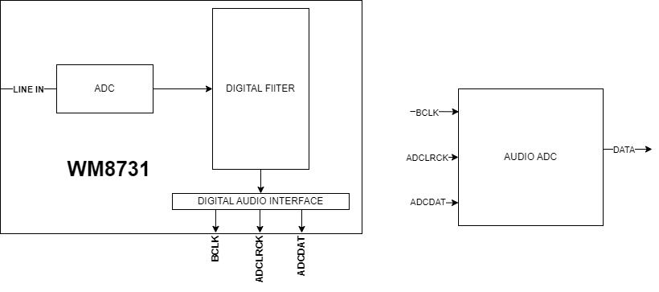

**5.3.4.2 Build Audio ADC:**

* **How pulses work in IC**

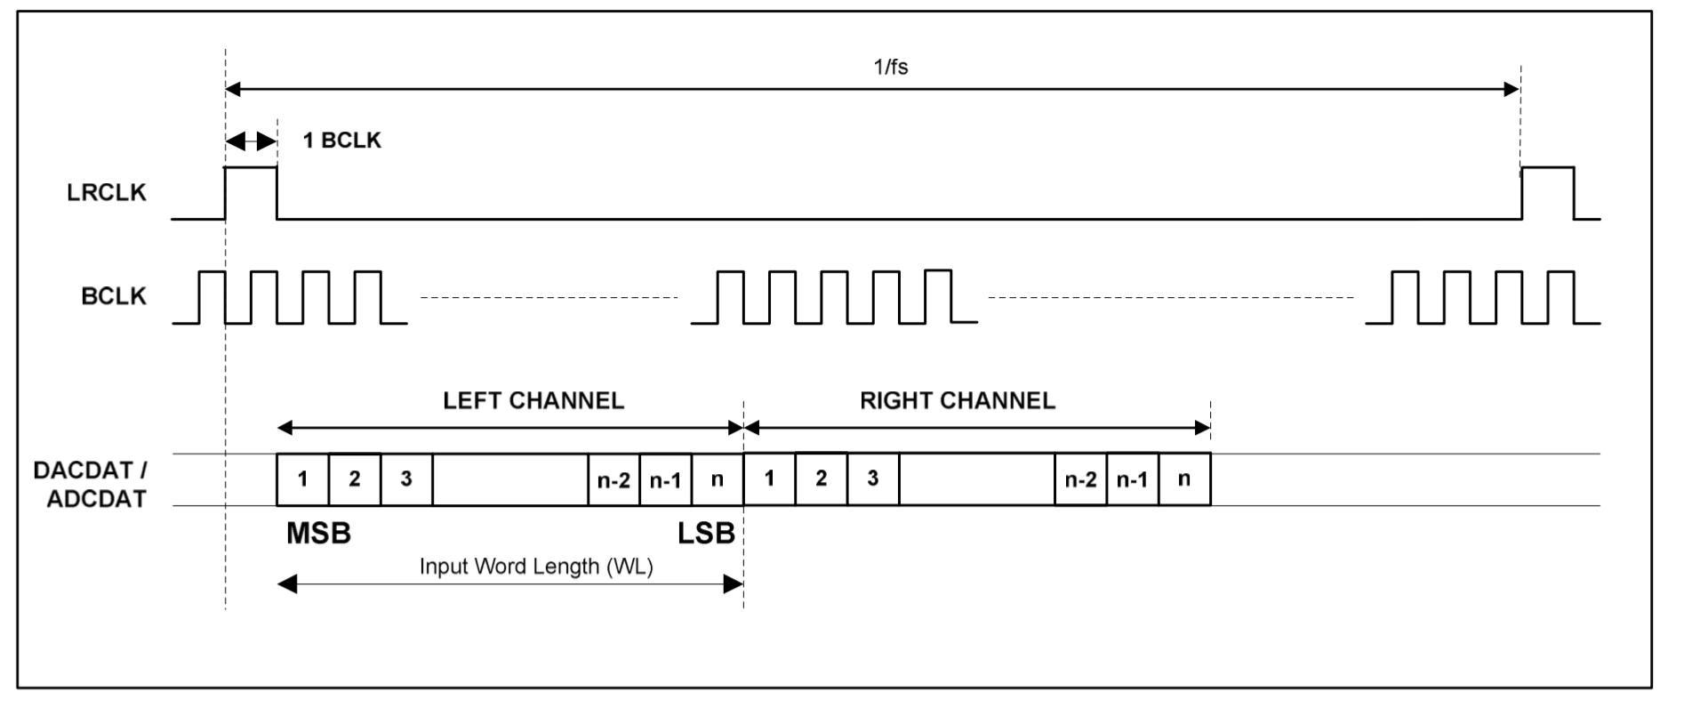

***Digital Audio Data Timing – Master Mode***

**Explain:** The WM8731 IC is initialized to use 16-bit audio samples. This means that in each pair of left and right samples, a total of 32 bits will be used. Bits are read/written from the highest bit (MSB) to the lowest bit (MSB) in order from left to right when LRCLK is low.

* **Code**

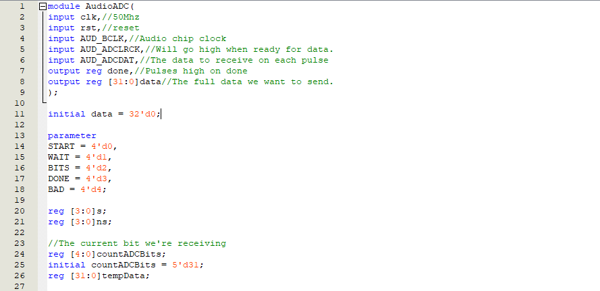

***Signal Declaration***

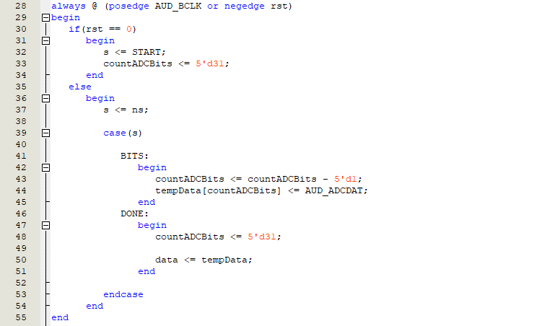

***Get Signal From IC WM8731***

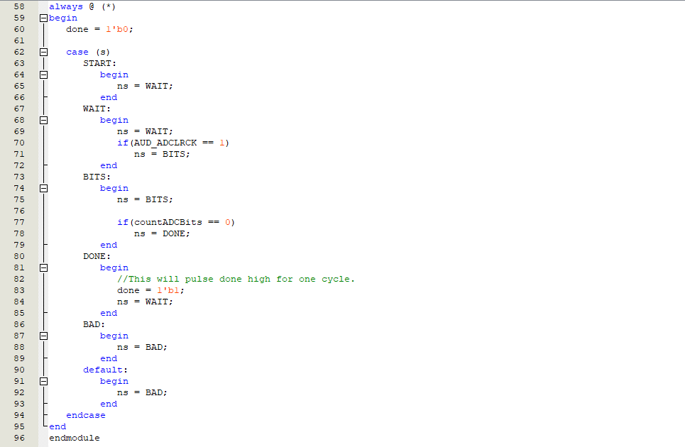

***State Machine***

**5.4.3.3 RTL Viewer:**

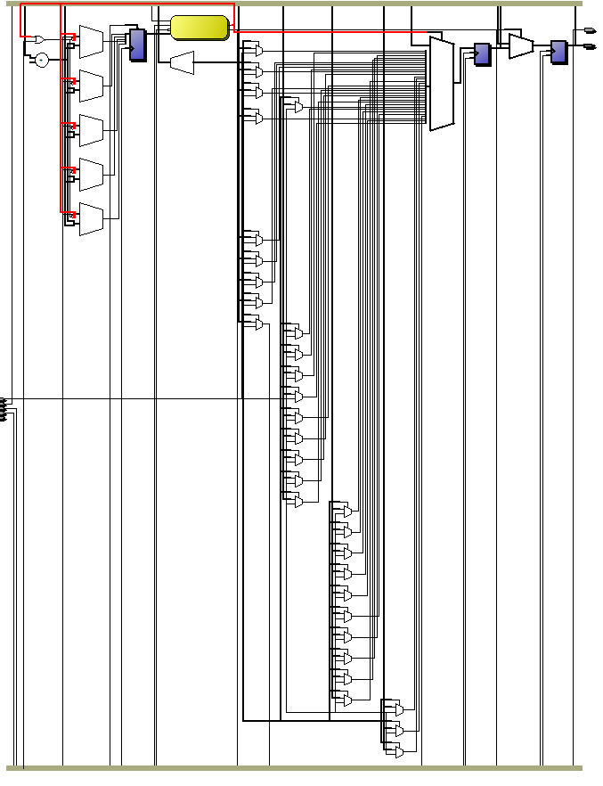

***Circuit Of Audio ADC***

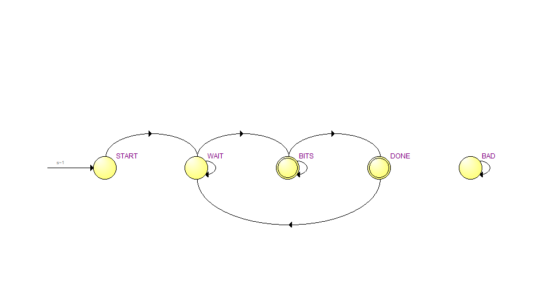

***State Machine***

**5.3.5 Audio DAC:**

When the Audio ADC is built, we have the data copied from the IC and now the DAC's task will be to take data from the ADC and transmit it back to IC WM8731. At this time, IC WM8731 will convert this data into Analog signals and send the signals to Line Out. From there, we will hear sound through standard devices that support sound playback such as headphones and speakers. And it is also the premise to modify the sound quality as desired (High Pass, Low Pass Filter..etc).

**5.3.5.1 Block Diagram:**

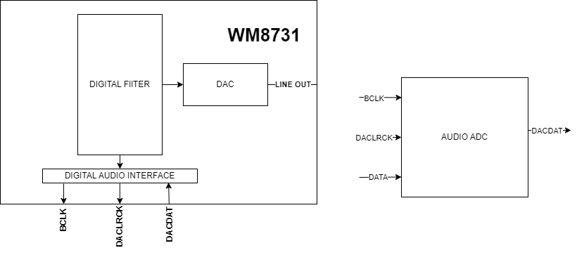

**5.3.5.2 Build Audio ADC:**

* **Code**

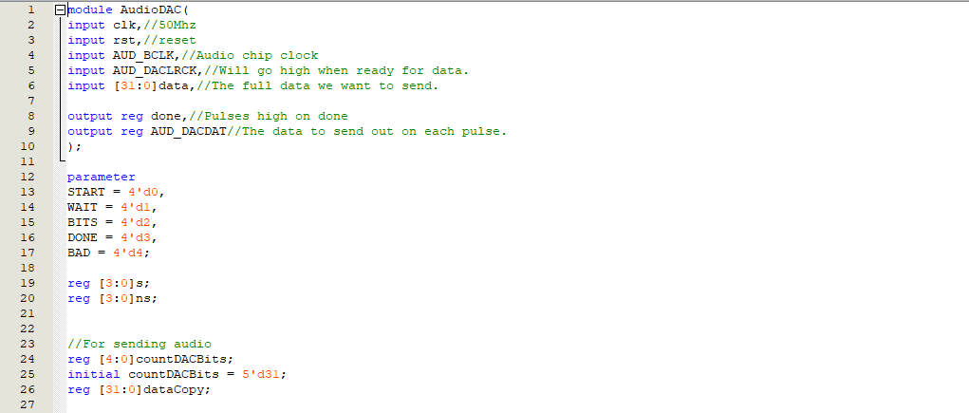

***Signal Declaration***

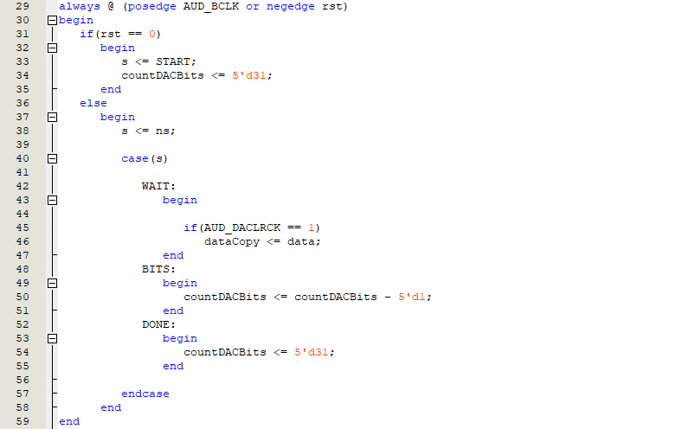



***Use Data Copy***

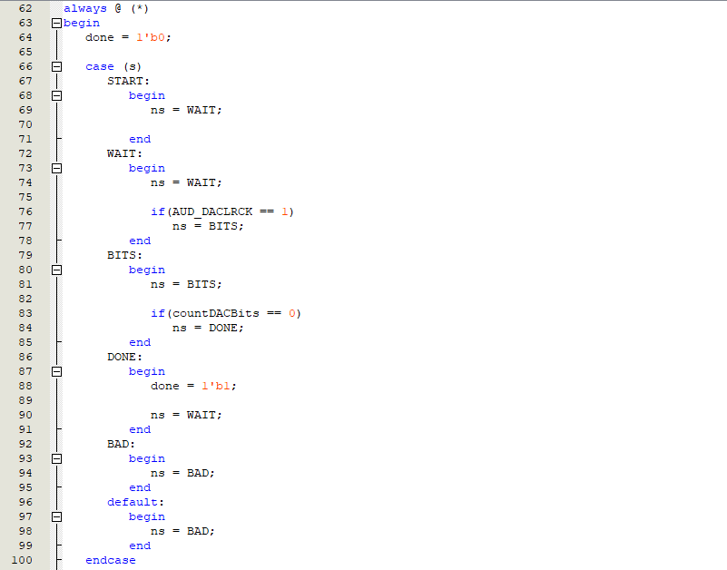

***State Machine***

**5.3.5.3 RTL Viewer:**

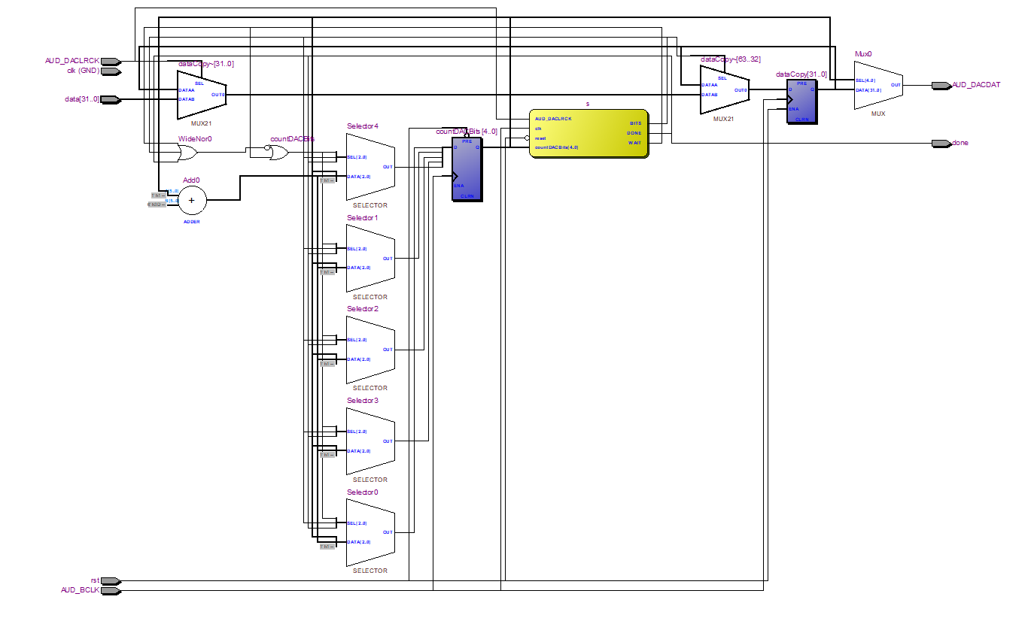

***Circuit Of Audio DAC***

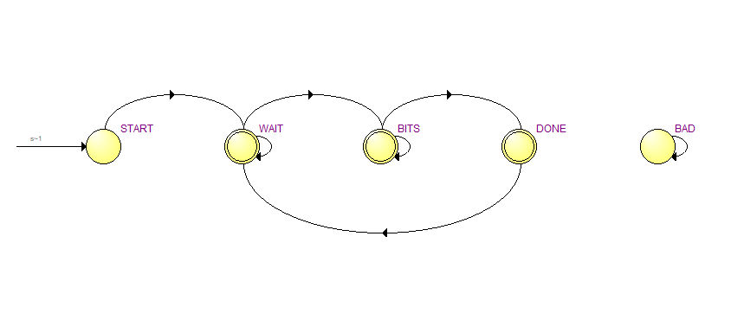

***State Machine***

**5.3.6 Low Pass Filter:**

**5.3.6.1 Definition:**

A low pass filter allows low frequency sounds to pass through unhindered while attenuating higher frequency sounds. If you pass music through a low pass filter, it will sound very "deep" and bass-like.

**5.3.6.2 Build Low Pass Filter:**

Pseudocodes implemented in C before being build on the FPGA:

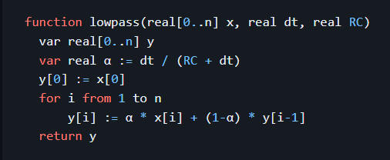

* **Code:**

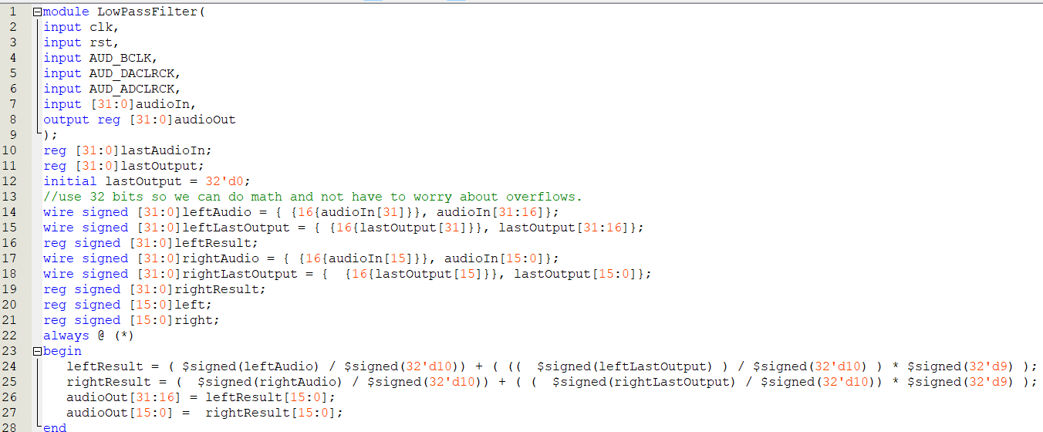

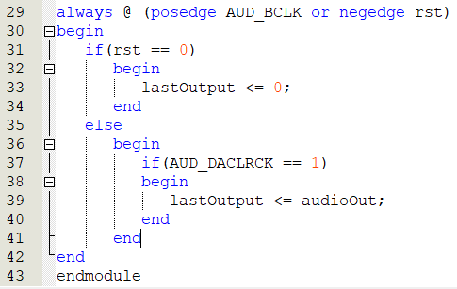

**5.3.6.3 RTL Viewer:**

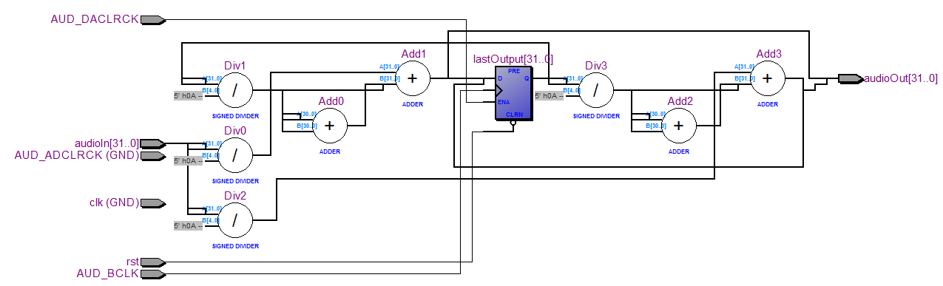

**5.3.7. High Pass Filter:**

**5.3.7.1 Definition:**

* A high pass filter is similar to low pass filter, but it only allows higher frequency sounds to pass through and attenuates lower frequency sounds. This results in audio that sounds very "tinny".

**5.3.7.2 Build High Pass Filter:**

* Pseudocodes implemented in C before being implemented on the FPGA:

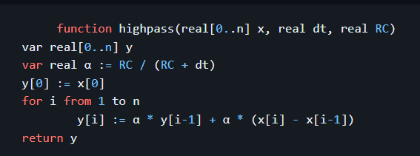

* Code:

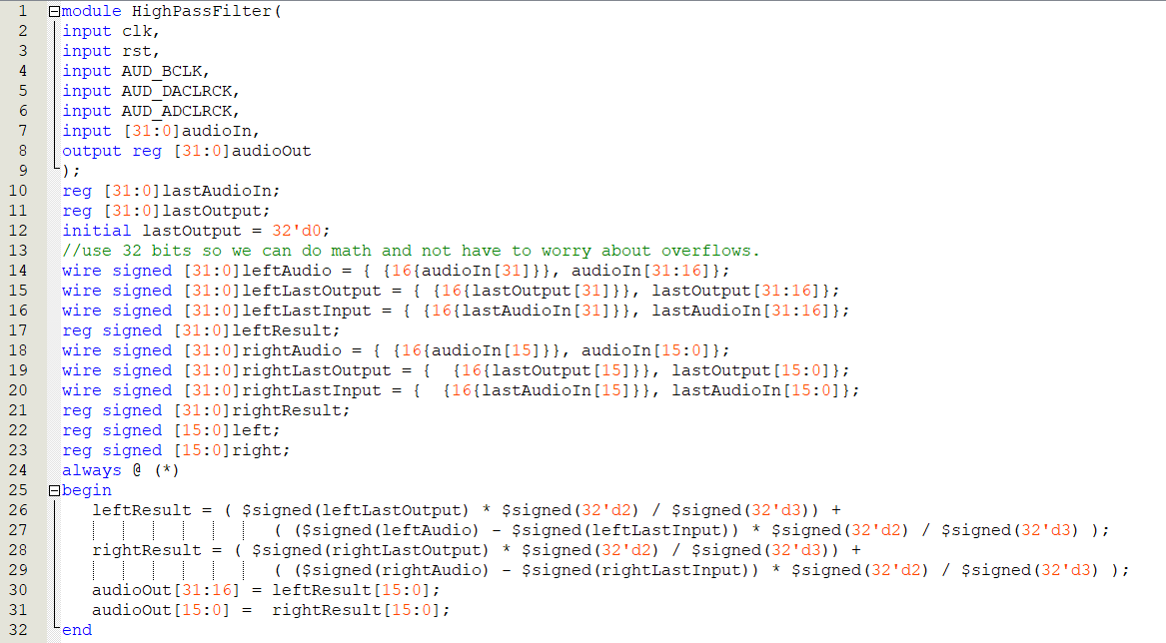

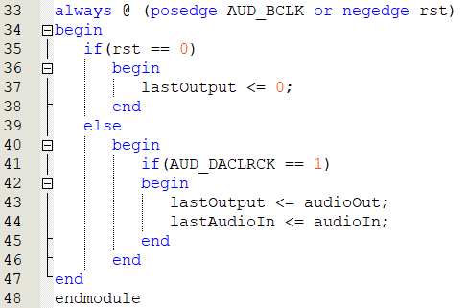

**5.3.7.3 RTL Viewer:**

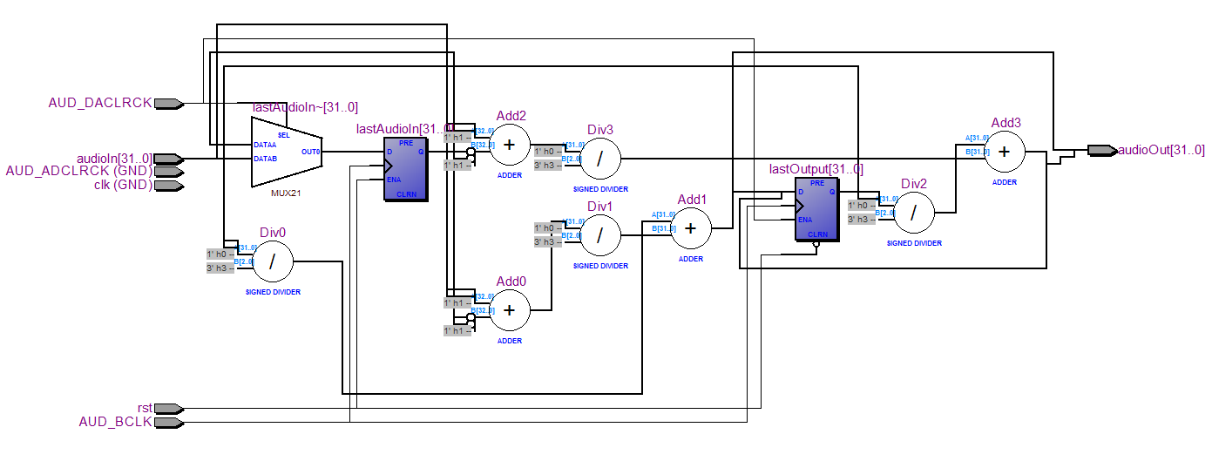

**Chapter 6: System deployment**

**6.1. Small modules used to build the system:**

1. **Debouncer module (used to interact with SWITCH on DE2 kit):**

This module is designed to eliminate or minimize the effects of noise or unstable movements in the input signal. Debouncers are often used in digital systems to ensure that a stable and clean signal is used for further processing.

**Module declaration:**



**In there:**

- The rst signal is an asynchronous reset signal

- The clk signal is a clock signal

- The inp signal is the input signal before noise processing

- The out signal is the output signal after noise processing

**Initialize initial value:**

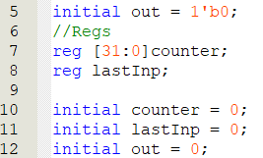

Handle noisy data in the always block when the clock triggers the rising edge and the reset signal is asynchronous:

+) If reset signal = 0

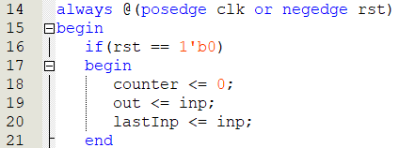

The counter value is reset to 0, out is updated with the current input signal (inp), lastInp is updated with the current input signal (inp).

+) If reset signal != 0

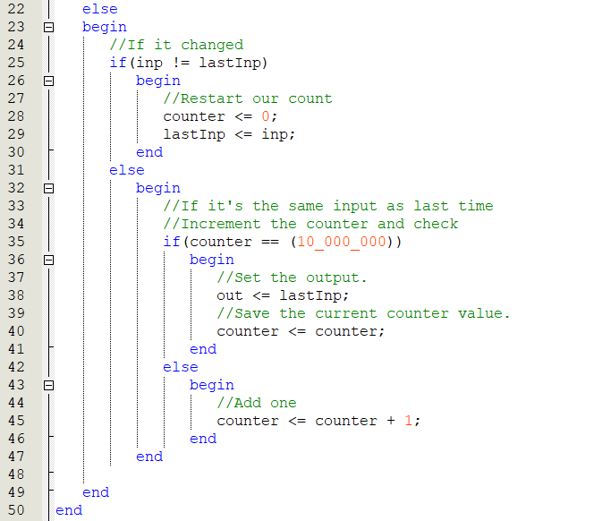

- If inp != lastInp (the current input signal is different from the previous one), then we will reset the value of the counter and update lastInp

- If the counter value reaches 10_000_000, we will update the output value (out) and preserve the current count value.

- If the counter has not reached 10_000_000, we will increase the counter value.

- In conclusion, this Debouncer module uses a counter to stabilize the input signal (inp) and create a debounced output signal (out). The debounce process involves resetting the counter every time the input signal changes and updating the output signal when the counter reaches a specific value.

1. **Module Visualizer (Used to display the volume of the sound on kit DE2):**

A simple visualizer was created to show the current volume of the audio passing through the DE2 board. The louder the sound, the more LEDs in a row were lit up.

The following simple algorithm was used: 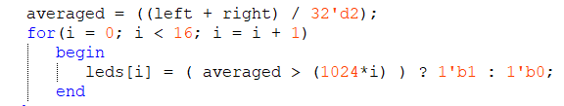

Visualizer Module:

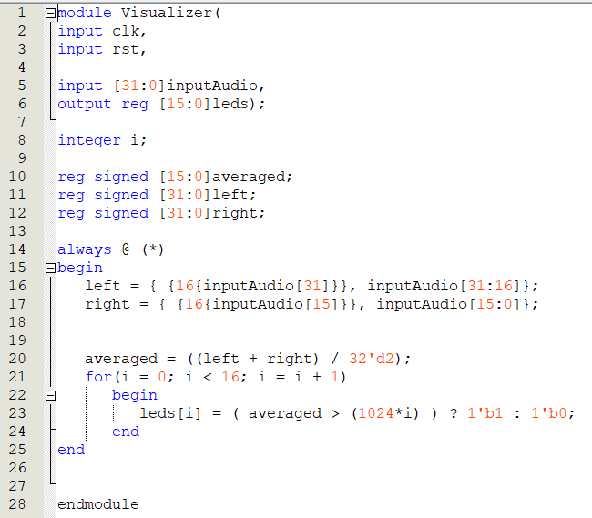

Where inputAudio is the input audio value and leds is the output value corresponding to the leds in order from 0 to 15 on the DE2 kit.

1. **Module output 7Seg (Use to display Led 7 Segment in KIT):**

The purpose of this module is to take a 4-bit input (inp) and generate a 7-bit output (display) that corresponds to the pattern of segments needed to display the corresponding decimal digit on a 7-segment display.

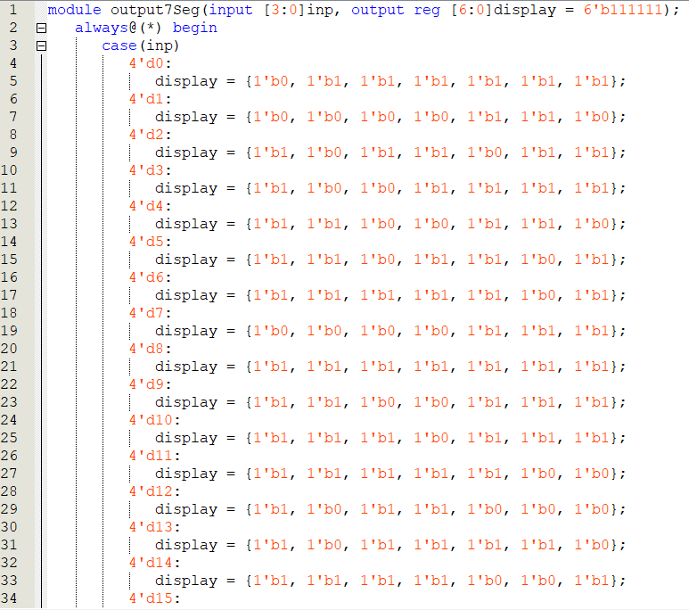

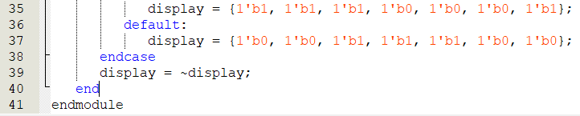

**6.2. Combine small modules into main modules:**

After obtaining the component modules, we assemble the main module that we will use to operate with the DE2 kit with the module name AudioOutputTest.

**Module AudioOutputTest:**

* Module declaration

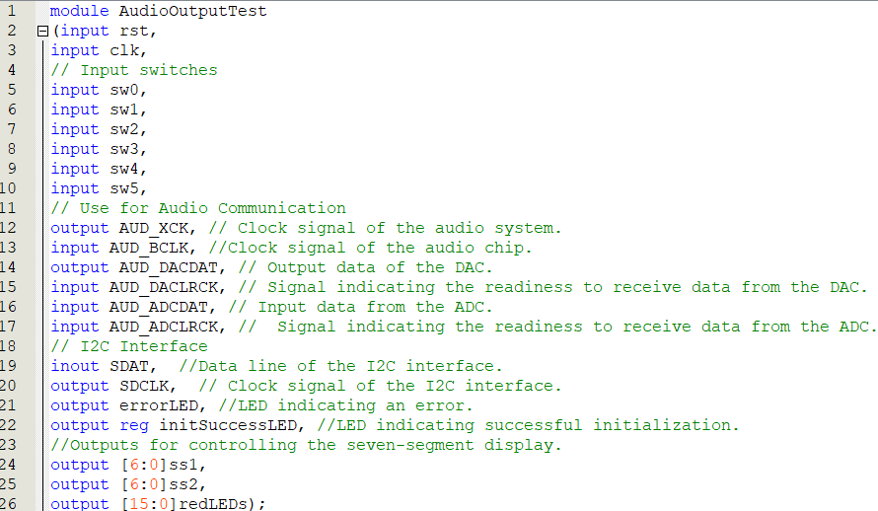

* The always function with the audioClkCounter counts clock pulses and ensures that an event occurs every 48,000 clock cycles.

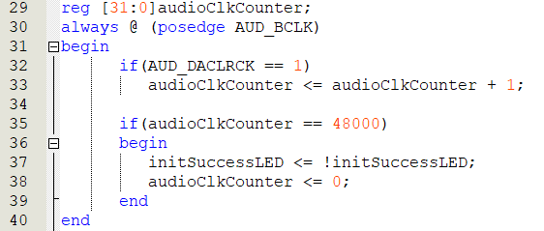

* Filter noise on switch inputs on kit DE2 using the Debouncer component module:

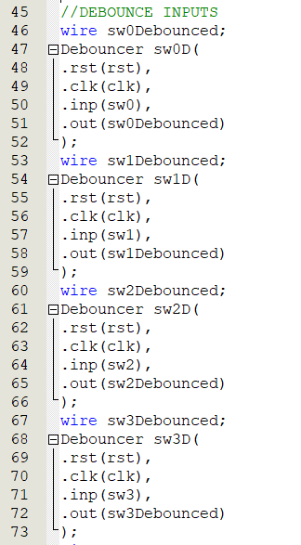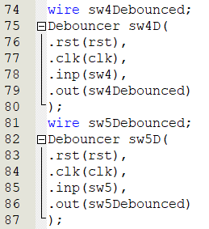

* Communicate and initialize the audio chip using the AudioInit module:

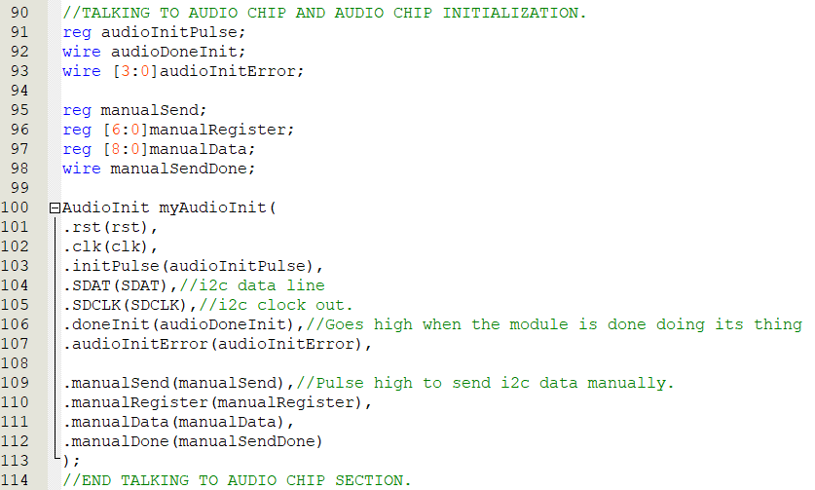

- Use DAC and ADC to receive and output audio data through 2 modules AudioDAC and AudioADC:

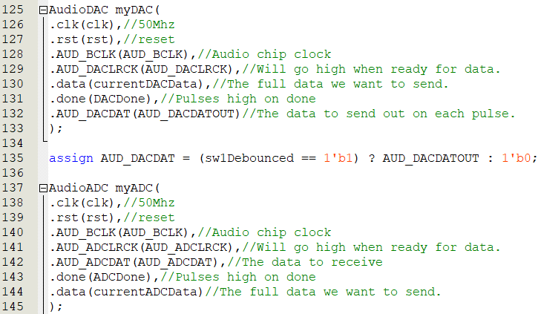

* Use the Visualizer module to display the volume through the LEDs on the DE2 kit:

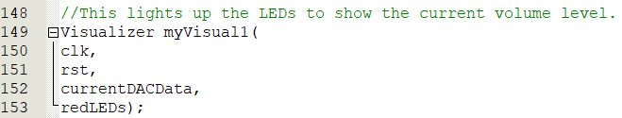

+ Use the modules LowPassFilter, HighPassFilter to high-pass and low-pass filter with the input being the data output after passing through the ADC and we can create a middle-pass filter (MidPassFilter) by combining high-pass filtering and filtering. low pass (using the output of the LowPassFilter module to pass into the HighPassFilter module, we will have the output of the HighPassFilter module which is the audio signal when it has been middle pass filtered):

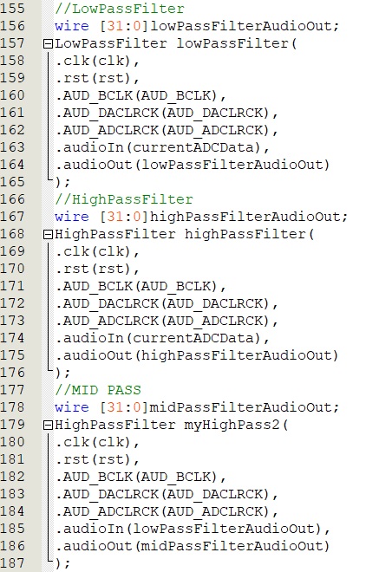

+ Optional control of functions based on switch 4, switch 3 and switch 2 inputs: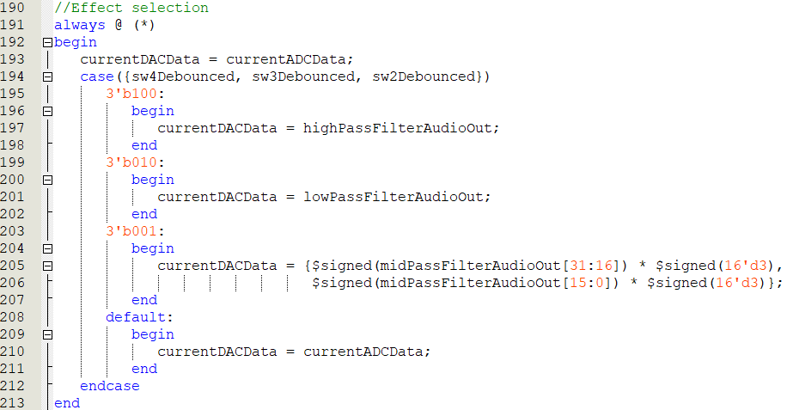

If switch 4, switch 3, and switch 2 have values of 1, 0, 0 respectively, the audio data will be **high-pass filtered**.

If switch 4, switch 3, and switch 2 have values of 0, 1, 0 respectively, the audio data will be **low-pass filtered**.

If switch 4, switch 3, and switch 2 have values of 0, 0, 1 respectively, the audio data will be **middle-pass filtered**.

If switch 4, switch 3, and switch 2 have values of 0, 0, 0 respectively, the audio data will remain as **original**.

* State machine used to control the state of the module:

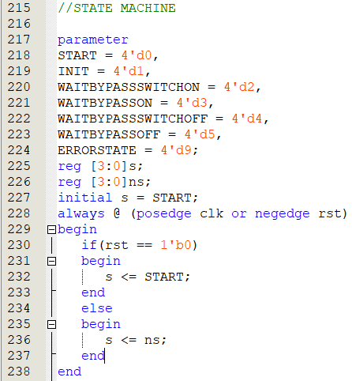

With clock raised edge and asynchronous reset.

If reset = 0, the current state will be reset to START.

If reset != 0, the current state will be updated according to the next state.

* The always function is used to control the state and the next state:

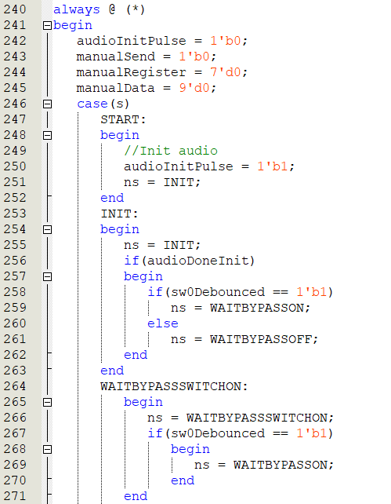

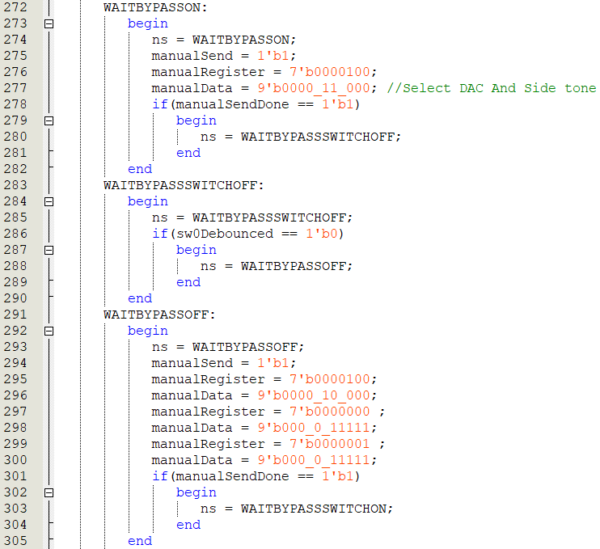

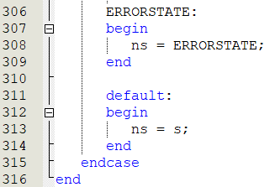

* With audioInitPulse, manualSend, manualRegister and manualData are variables used to send audio chip commands and data, ns is a variable used to store the next state and s is a variable used to store the current state.
* START state: Initial state where the audioInitPulse signal is set to 1 to start the audio initialization process.
* INIT state: state checks whether audio initialization has completed or not. If completed and the sw0 button is pressed, the state machine changes to the WAITBYPASSON state, otherwise it changes to WAITBYPASSOFF.
* WAITBYPASSSWITCHON state: Waiting state until the sw0 button is pressed again. If this happens, switch to WAITBYPASSON.
* WAITBYPASSON status: Status that sends commands and data to the audio chip to enable "Bypass ON." Switch to WAITBYPASSSWITCHOFF when finished.

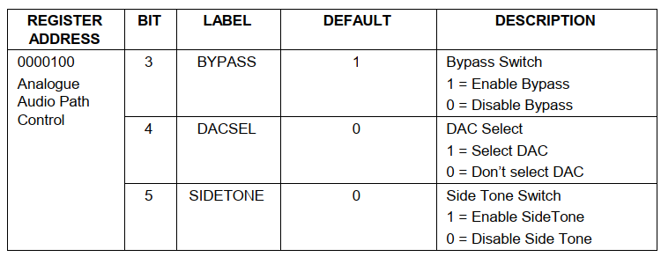

* WAITBYPASSOFF state: Same state as WAITBYPASSON, but activates "Bypass OFF." When completed, change the status to WAITBYPASSSWITCHON.

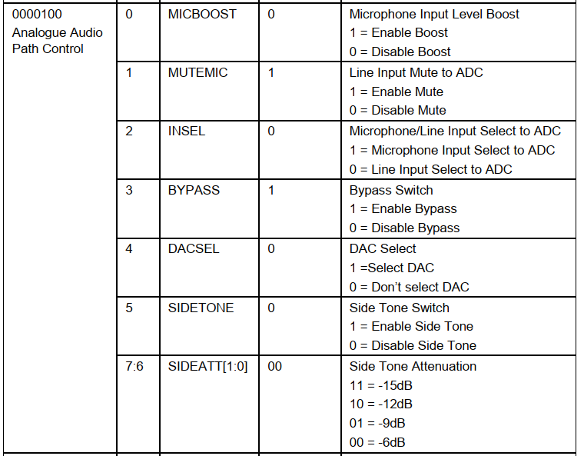

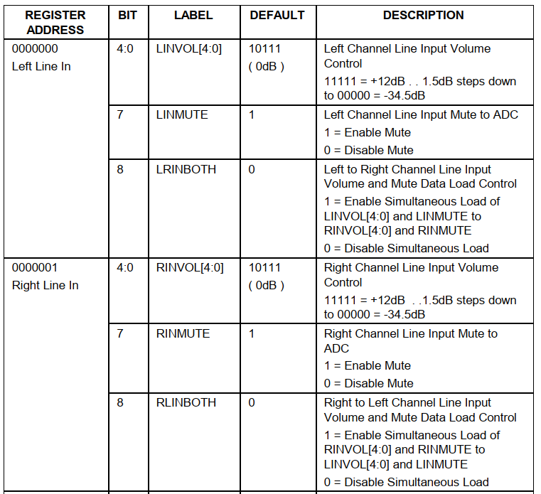

* ERRORSTATE state: Error state, can be used to handle unexpected situations.

**RTL Viewer:**

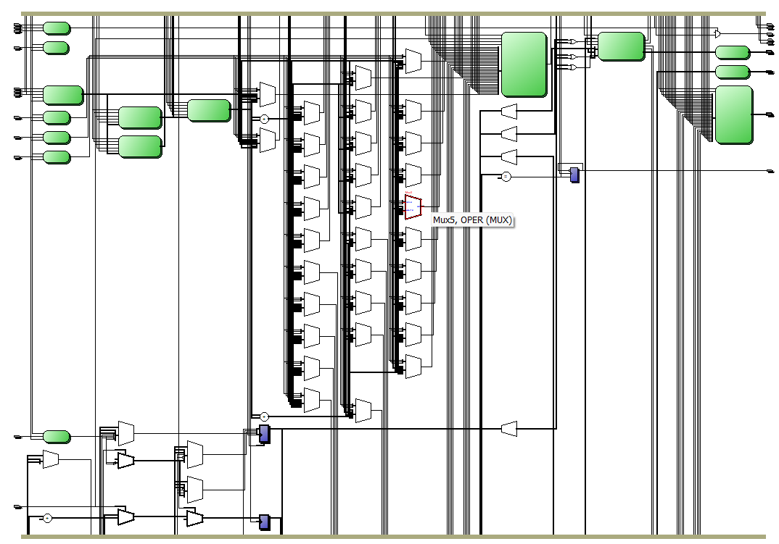

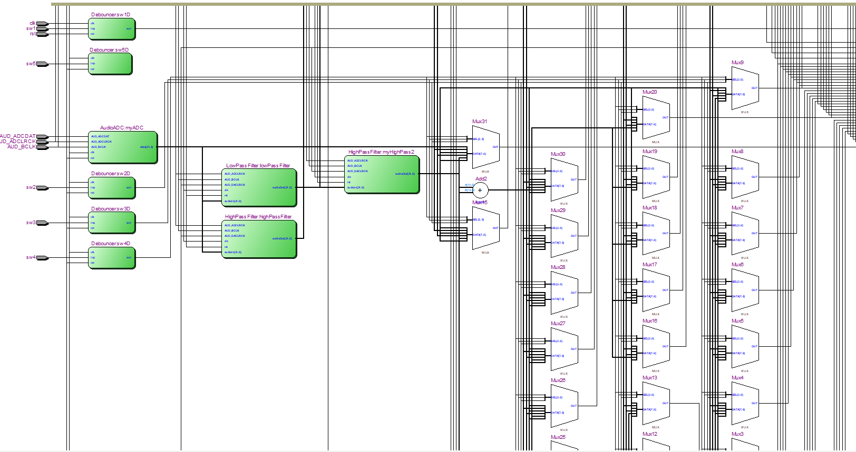

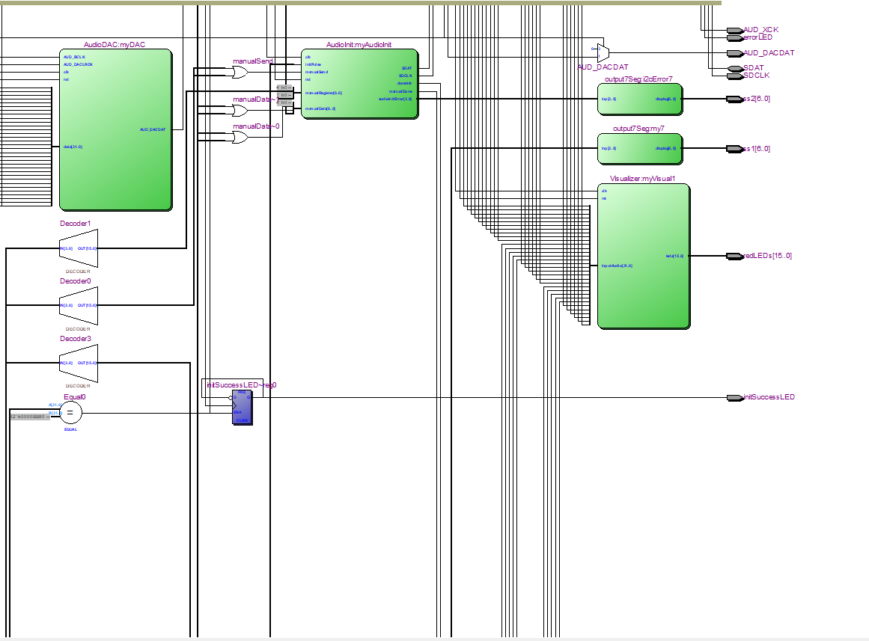

**Chapter 7: Experimental results, evaluation and development directions**

1. **Simulation results on Modelsim:**
2. **Simulation results of the High Pass filter and Low Pass filter functions:**

Because Highpass and Lowpass Filter both receive the same data from the audio wav file and only have different functions, we can create a common testbench file to test the highpass and lowpass filters:

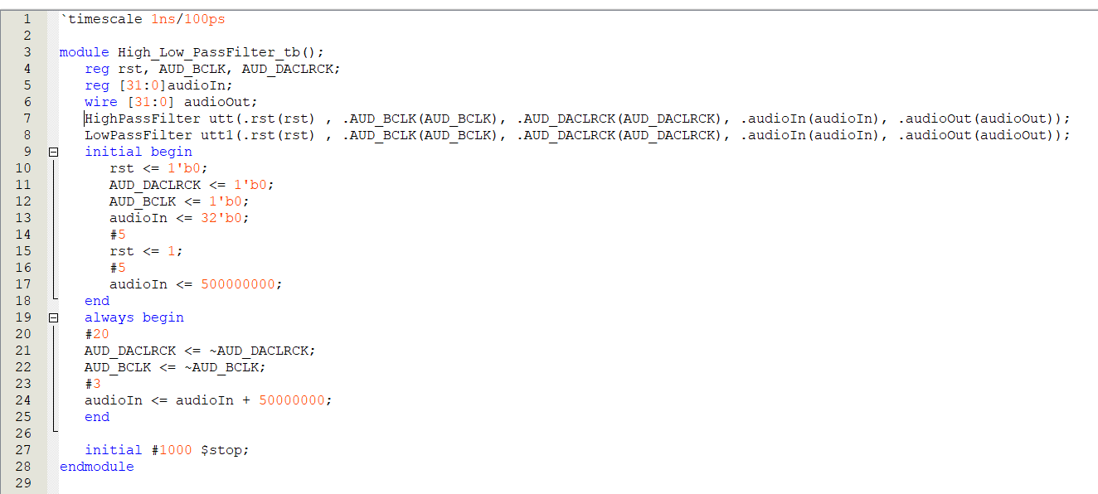

**Note:** When running this testbench file, when running the Highpass Filter module, comment the foot attachment of the Lowpass Filter module and vice versa.

Previously, in order for the testbench to run properly and output values, in the two modules we had to initialize the values for the following signals in the initial block:

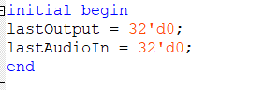

Like other regular testbench files, this testbench file also has basic components such as timescale to set the time unit, declare the testbench module, perform pin attachment, and initialize the input signals to 0. We consider that the AUD_BCLK pulse period is 40ns in the always block, in parallel with that we make AUD_DACLRCK active high every time the clk pulse is active on the rising edge and after 3ns when the AUD_BCLK pulse is active on the rising edge and AUD_DACLRCK is active high, we new changes the input audio data by increasing it by 50000000 so that it can promptly save the previous output and input audio values. We let the testbench run for 1000ns then stop with the $stop function placed in the initial block.

**The simulation results of the Highpass Filter function are as follows:**

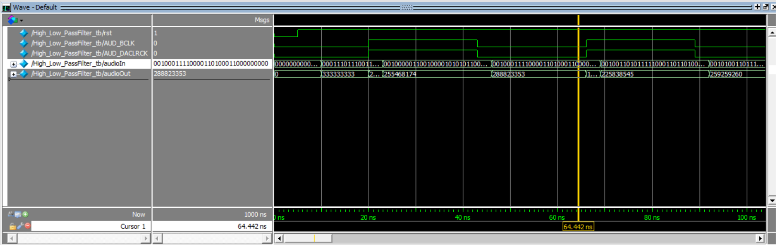

***Simulation Results***

Because the function of the circuit through the cycles is similar, we only need to evaluate the correctness/falseness of the circuit through the first cycles. We put the output in base 10 to make it easier to check. We check whether the simulated signal is correct according to the formula implemented in the code as follows:



With alpha coefficient = ⅔, y[i] = Left/RightResult, y[i-1] = Left/RightLastOutput, x[i] = Left/RightAudio, x[i-1] = Left/RightLastInput.

* In the first 20ns, the AUD_BCLK pulse does not trigger a rising edge. For the first time, all inputs are initialized to 0. During the first 5ns, input rst = 0, so the output is 0. Then, we give rst goes up to 1 but the transmitted audio signal at the input is still 0 so the output is still 0. Next, after 5ns we transmit the input audio, at this time the AUD_BCLK pulse has not triggered the rising edge, so the input audio signal output depends only on the input audio signal.
  + The input signal now is: 0001110111001101_0110010100000000 , then:
  + LeftAudio = 0000000000000000_0001110111001101
  + RightAudio = 0000000000000000_0110010100000000
  + LeftLastInput = LeftLastOutput = RightLastInput = RightLastOutput = 0. So:
  + LeftResult = 0000000000000000_0001001111011110
  + RightResult = 0000000000000000_0100001101010101
  + AudioOut = 0001001111011110_0100001101010101 = 333333333 the base 10 number system is consistent with the simulation results.
* After the AUD_BCLK pulse raises the edge and at the same time makes AUD_DACLRCK active high for a period of 3ns to save the previous input and output values, we proceed to change the input input. The transmitted signal at this time is: 0010000011001000_0101010110000000, then:
* LeftAudio = 0000000000000000_0010000011001000
* RightAudio = 0000000000000000_0101010110000000
* LeftLastInput = 0000000000000000_0001110111001101
* RightLastInput = 0000000000000000_0110010100000000
* LeftLastOutput = 0000000000000000_0001001111011110
* RightLastOutput = 0000000000000000_0100001101010101

We can calculate:

* LeftResult = 0000000000000000_0000111100111011
* RightResult = 0000000000000000_0010001010001110
* audioOut = 0000111100111011_0010001010001110 = 255533710 the base 10 number system is consistent with the simulation results.

The remaining cases are similar to above. Therefore the Highpass Filter has been correctly simulated.

**The results of simulating the function of the Lowpass filter are as follows:**

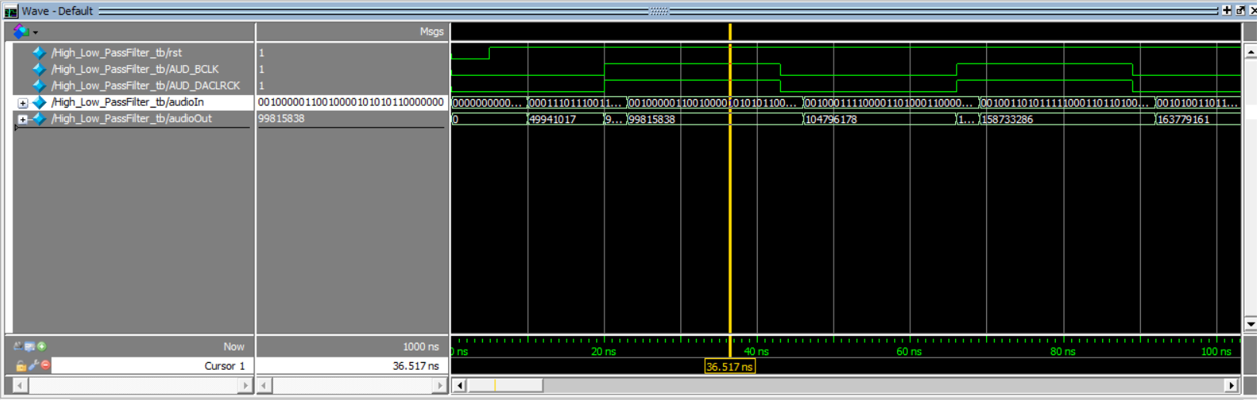

***Simulation Results***

Similar to Highpass, the function of the circuit through the cycles is similar, so we only need to evaluate the correctness/wrongness of the circuit through the first cycles. We put the output in base 10 to make it easier to check. We check whether the simulated signal is correct according to the formula implemented in the code as follows:



With alpha = 1/10 , y[i] = Left/Right Result, y[i-1] = Left/RightLastOutput, x[i] = Left/RightAudio.

* In the first 20ns, the AUD_BCLK pulse does not trigger a rising edge. For the first time, all inputs are initialized to 0. During the first 5ns, input rst = 0, so the output is 0. Then, we give rst goes up to 1 but the transmitted audio signal at the input is still 0 so the output is still 0. Next, after 5ns we transmit the input audio, at this time the AUD_BCLK pulse has not triggered the rising edge, so the input audio signal output depends only on the input audio signal.
  + The input signal at this time is: 0001110111001101_0110010100000000 , then:
  + LeftAudio = 0000000000000000_0001110111001101
  + RightAudio = 0000000000000000_0110010100000000
  + LeftLastOutput = RightLastOutput = 0. So:
  + LeftResult = 0000000000000000_0000001011111010
  + RightResult = 0000000000000000_0000101000011001
  + AudioOut = 0000001011111010_0000101000011001 = 49941017 the base 10 number system is consistent with the simulation results.
* After the AUD_BCLK pulse raises the edge and at the same time makes AUD_DACLRCK active high for a period of 3ns to save the previous input and output values, we proceed to change the input input. The transmitted signal at this time is: 0010000011001000_0101010110000000, then:
* LeftAudio = 0000000000000000_0010000011001000
* RightAudio = 0000000000000000_0101010110000000
* LeftLastOutput = 0000000000000000_0000001011111010
* RightLastOutput = 0000000000000000_0000101000011001

We can calculate:

* LeftResult = 0000000000000000_0000010111110011
* RightResult = 0000000000000000_0001000110011110
* audioOut = 0000010111110011_0001000110011110 = 99815838 the base 10 number system is consistent with the simulation results.

The remaining cases are similar to above. Therefore the Lowpass Filter has been correctly simulated.

1. **Results of functional simulation of the entire circuit:**
2. **Visualizing audio signals in Python:**

To process digital input audio signals such as mp3 and wave audio files, first we need to know the characteristics of the audio file such as frequency, sampling rate, amplitude, etc. We can use python to visualize all these features of the sound.

**2.1 Python library that supports audio processing:**

Some python libraries support audio processing such as librosa, scipy, torchaudio. All of them allow you to read audio files in different formats. We carry out implementation on google colab.

**Implementation steps:**

1. First, we need to have an existing audio file saved on Google Drive. In this example, the audio file is named audiotest.wav.
2. Connect to drive:

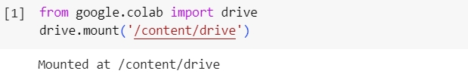

1. Use the librosa library specializing in audio processing to get samples and characteristics of audio files:

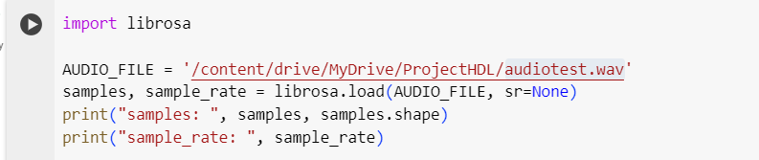

We have output which are audio samples taken from the audio file and the sampling rate of this audio file is 44100. These samples are expressed as scientific numbers. For example, 2.31e2 would be 2.31 times 10 to the 2nd power (2.31 * 10^2).

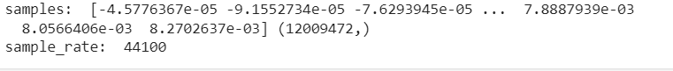

1. Check the size of the audio file and the data type of the audio samples:

Audio Data is obtained by sampling the Sound Analog Signal over a period of time and measuring the amplitude value at each sampling time. Audio Data is saved as a file in one of the compression formats (.mp3, .wav, ...). When read out by the processing libraries, it is decompressed and converted into a Numpy Array. This data array is the same no matter what format the Audio Data is saved in.

In memory, Audio can be considered a series of amplitude values over time. For example, in this file, the sampling frequency is 44100Hz, so every 1s of Audio will have 44100 amplitude values.

The following code retrieves the music file size, sampling frequency, and data type of the samples:



We retrieve 100 samples starting from sample 11995100 to sample 11995200. The samples are retrieved as a 1-dimensional array of 100 elements. We have output that clearly shows the data type of the samples, numpy.ndarray:

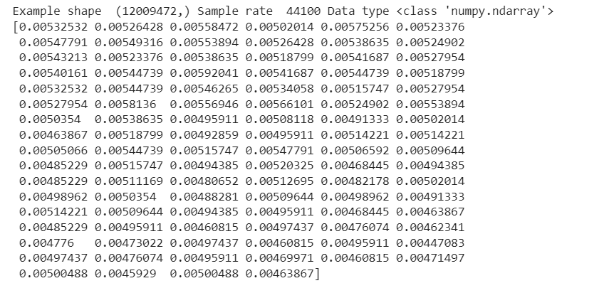

Each element in this array represents the amplitude of the sound wave at a 1/sample_rate duration of seconds. For example, with the audio file above being 272 seconds long with a sample rate of 44100 Hz, the number of samples in the file will be 272 * 44100 = 11995200.

1. Visualize sound waves as a graph:

We use the matplotlib library whose input is all audio samples at different times of the music file through the following code:

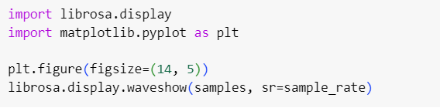

We have the output as a graph representing the waveform of the music file with the x axis representing the time from the start to the end of the music file. The y axis represents the amplitude of the sound at each different time.

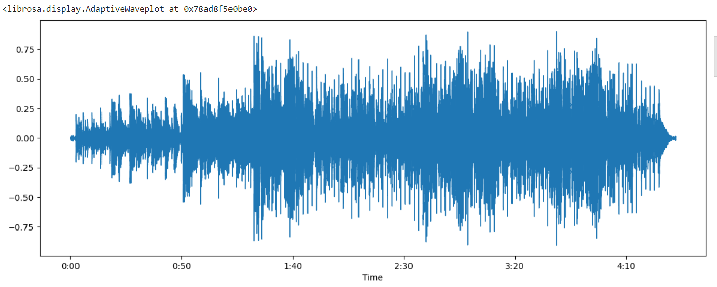

Looking at the waveform above, we see that it is still very confusing because we cannot distinguish the amplitude of the signals at different time periods because the sound in the music changes many times in a very short period of time. Therefore, to be more intuitive, we divide the time period and consider the amplitude variation of the signal during that time period. In this example, we perform a survey on a small interval of 50 samples (on the interval 50/44100 = 0.00113(s) = 1.13(ms)) from sample 50000 to sample 50050 to see the amplitude variation in this interval.

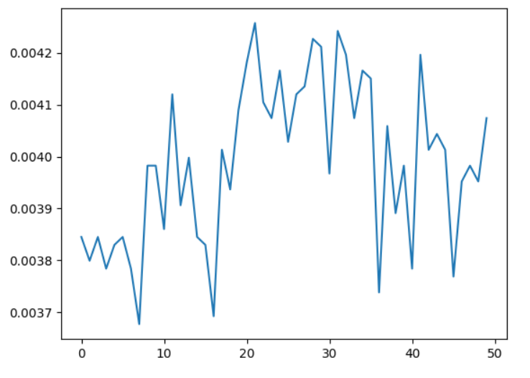

We can see this recording is only 1/100th of a second long. But even this short recording is a complex mix of different sound frequencies. There are some bass sounds, some mid-range sounds, and even some high-intensity sounds. But when these different frequencies combine, they create the complex sound of the human voice.

**2.2 Visualize the audio signal after passing through a low-pass filter and a high-pass filter:**

* **Low Pass Filter:** For the purpose of this article, we’ll define a lowpass filter as a filter that attenuates frequencies above a certain frequency, called the *cutoff frequency*. The cutoff frequency is typically defined as the frequency at which the attenuation is already 3 dB. The frequencies below the cutoff frequency aren’t affected by the filter.
* **High Pass Filter:** Contrary to a lowpass filter, a highpass filter attenuates all frequencies below the cutoff frequency.
* **All Pass Filter:** is a filter that does not attenuate or boost any frequencies but introduces a frequency-dependent delay. That means that a single allpass filter won’t introduce any audible change in the signal. Only when we use this filter in some context, can we hear its true power.  
  **“Frequency-dependent delay”**: the higher the frequency, the later it will appear at the filter’s output. The amount of phase delay can be seen in the phase response of the allpass filter.If this delay was large and we put a signal with a flat spectrum at the input, we could hear a tone rising in frequency at the output; the lowest frequency would appear immediately at the output, whereas the highest would appear last, because it has the largest delay. In practice, this delay is too small to be audible. We can, however, observe its effect on the waveform in the time domain.  
  This effect can be seen in Figure 4. There, 3 nicely aligned sines (left) pass through an allpass filter and appear misaligned at the output (right).

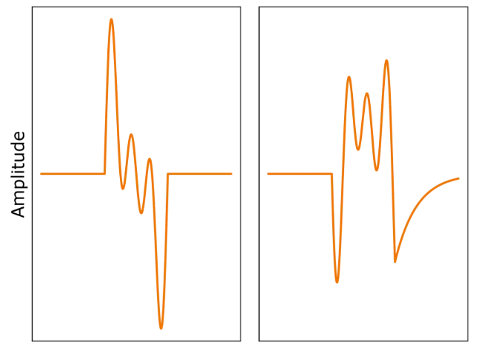

***Figure 4: (Left) A superposition of 3 sines. (Right) The same 3 sines after passing through an allpass filter.***

At the output, the frequency content is the same but the relative phase of the sines changed. At the same time, the output sounds exactly as the input.

Here is the formula for the [transfer function of the allpass filter](https://thewolfsound.com/allpass-filter/#first-order-iir-allpass):

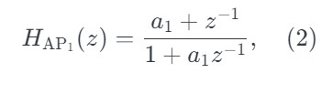

**Where**

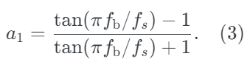

## **Allpass-Based Lowpass Filter:** We will add the output of the first-order allpass filter to the original input signal (the so-called *direct path*) as in Figure 6:

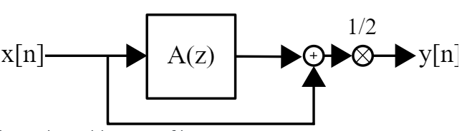

Since the phase shift at the Nyquist frequency is −*π*, we’ll obtain a phase cancellation at this frequency.  
At the direct current (DC) (frequency of 0 Hz), the output signal is not shifted with respect to the input (the signals are said to be *in-phase*). If we add two sines that have the same frequency and are in phase, we effectively obtain a sine at the same frequency which has the amplitude equal to the sum of amplitudes of the original sines. In the case of the discussed structure, the DC component at the input and at the output are identical. Therefore, the amplitude of the input DC component will double. Hence the multiplication by ½ so that we don’t exceed the [−1,1] range and avoid clipping.

Between these frequencies, the amplitude of sines will be gradually attenuated as the input signal and the output of the allpass filter gradually move out of phase with increasing frequency. The resulting magnitude transfer function can be seen in Figure 7. We obtained a lowpass filter!

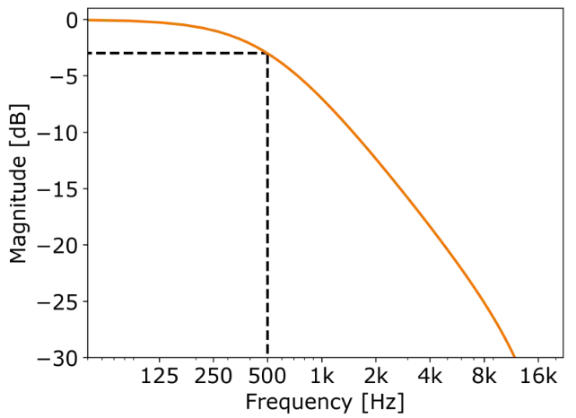

***Figure 7: Magnitude transfer function of the resulting lowpass filter.***

* **Allpass-Based Highpass Filter**: What if instead of adding the output of the allpass to the input signal, we subtracted it? The corresponding structure is shown in Figure 8

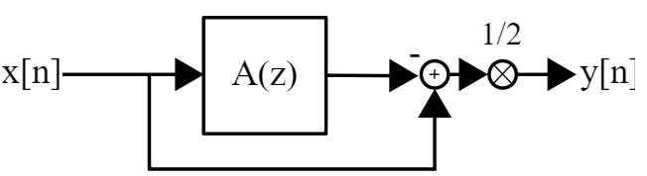

***Figure 8: Allpass-based highpass filter structure.***

By multiplying the output of the allpass by −1 we invert all the components in phase. Therefore, the frequency component at the Nyquist frequency, which was inverted in phase by the allpass filter, gets inverted again and is back in phase with the corresponding component of the input signal.

So the Nyquist frequency component before the multiplication by ½ in the structure in Figure 8 is doubled in amplitude.

Conversely, the DC component, which was previously in phase, is now negated. Therefore, the DC component is missing in the output signal of the structure from Figure 8.

In between these two frequencies, we get an increase in the magnitude of the transfer function with increasing frequency. The magnitude transfer function can be seen in Figure 9.

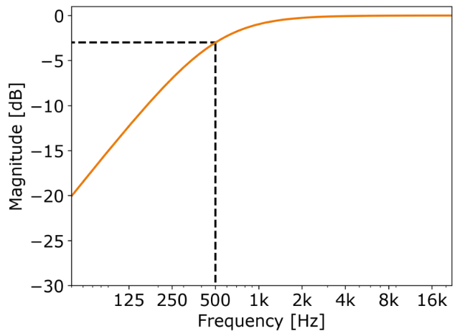

***Figure 9: Magnitude transfer function of the resulting highpass filter.***

We, thus, obtained a high-pass filter!

## **Python Implementation:**

First, we declare the libraries used:

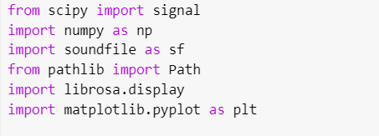

Next, we calculate the filter coefficient a1 of the allpass filter using the a1_coefficient() function according to the transfer function of the allpass filter:

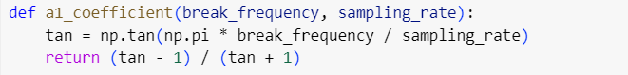

Next, we implement the allpass filter through the allpass_filter function, the input parameters of the function are the set of music signals to be processed (input_signal), the cutoff frequency (break_frequency) and the sampling rate (sampling_rate). We perform processing on each signal in the input signal set. The return value of the function is the signal after passing through the allpass filter (allpass_output):

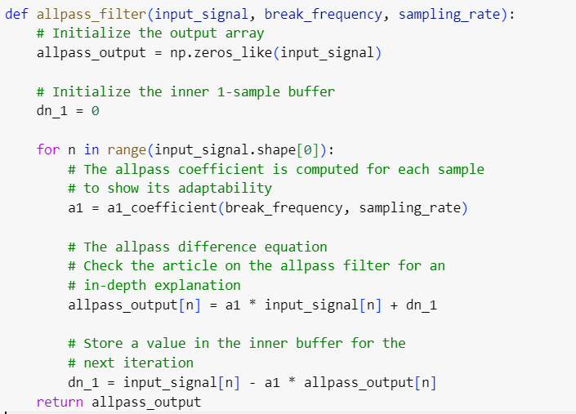

Next, we implement a mixed lowpass and highpass filter based on the allpass filter. The input parameters of the function are the set of music signals to be processed (input_signal), the cutoff frequency (break_frequency), and the sampling rate. (sampling_rate) and the specified signal is low pass or high pass filter (highpass) if highpass = False is low pass filter, and highpass = True is high pass filter, the amplitude coefficient is amplitude (here we do not change the amplitude Songs should default to a coefficient of 1). We take the output of the allpass filter and store it in the variable allpass_output. If we use high-pass filtering, we multiply this variable by -1. The output of this block is calculated by taking the input signal plus allpass_output then multiplying by ½ and multiplying by the amplitude coefficient as shown in the highpass and lowpass structure diagram mentioned above.

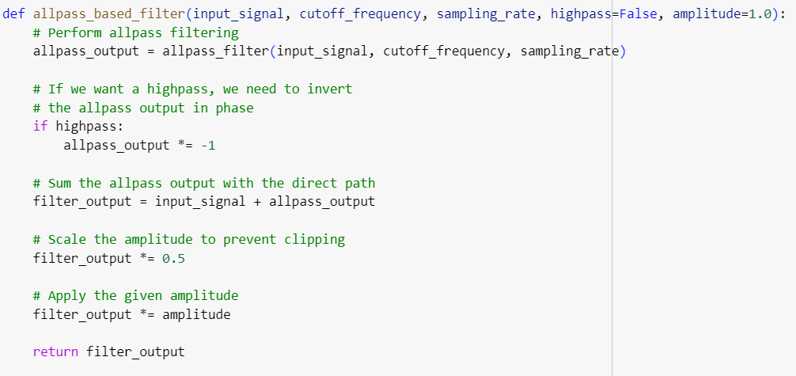

Next, we implement the input signal set, specifically the music signal that we sampled above. We declare the sampling rate (sampling_rate) to be 44100. We set the cutoff frequency to 30.0e-1 which is 30x10^-1 = 3. We also use the librosa function to visualize the sample signals on the graph:

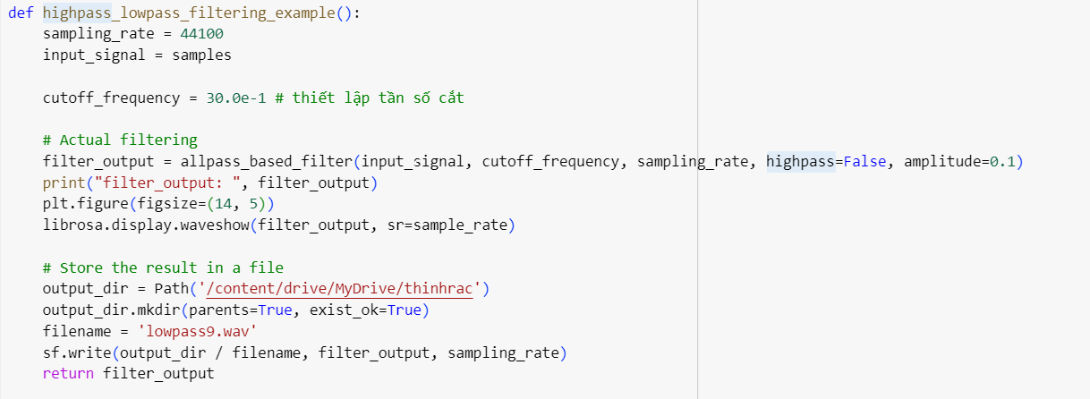

We have a graph of signals displayed as follows:

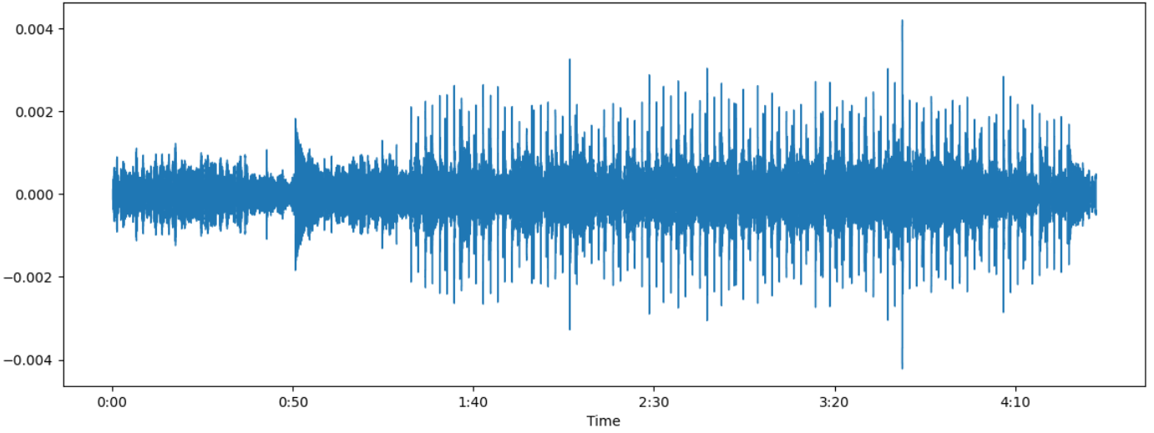

Looking at the graph, we see that the frequency of the signals is limited to the range (-0.004; 0.004). Therefore, high frequency signals have been filtered out compared to the signals in the original graph.

* With high pass filtering, we set the cutoff frequency to 30.0e02 = 30x10^50. In the code above, we change the input parameter Highpass = True in the high-lowpass mixed filter function to turn on the filtering function. Therefore, we have a graph of the signals displayed as follows:

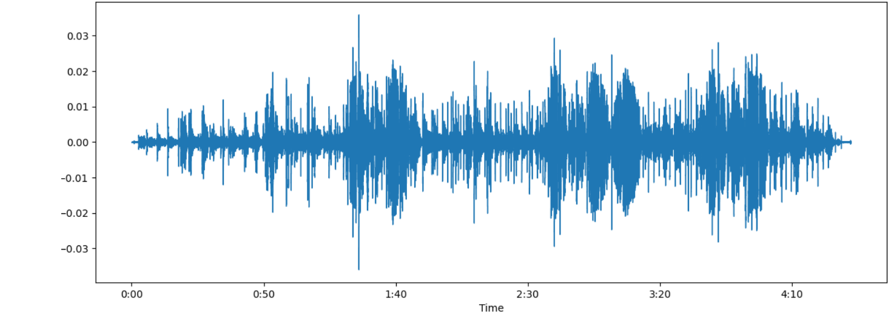

Looking at the graph, we see that the frequencies of the signals below (-0.01; 0.01) all disappear. Therefore, low frequency signals have been filtered out compared to the signals in the original graph.

1. **Actual Results:**

Result: [https://drive.google.com/file/d/1gBsnJ50TYzH08wYxY4w4BCu8JIJupOUS/view?usp=sharing](https://drive.google.com/file/d/1gBsnJ50TYzH08wYxY4w4BCu8JIJupOUS/view?usp=sharing&fbclid=IwAR2lfqwk1EkLqgh7TAi8rp9xSvn__xG3u1WSqQ562gdamqQPUuQd-USMDFA)

-Based on the video above, we can see the sound processing results on the DE2 FPGA kit running exactly as we expected.

1. **Development:**

* Although the purpose of this project is to apply sound processing on the FPGA DE2 kit successfully but in the future, we want to improve and develop this sound processing project in a number of other more advanced research directions, including:

-Can be developed into a larger system such as applying audio processing on the DE2 FPGA kit to implement a game console.

-It is possible to develop sound processing into a music player that can store multiple songs using the DE2 kit’s internal memory without having to use the Line In port to capture audio.

-Several other audio processing functions can be added.

**References:**

1. [**https://thewolfsound.com/allpass-based-lowpass-and-highpass-filters/**](https://thewolfsound.com/allpass-based-lowpass-and-highpass-filters/)
2. [**https://tiensu.github.io/blog/68_audio_deep_learning_part_2/**](https://tiensu.github.io/blog/68_audio_deep_learning_part_2/)
3. [**https://thewolfsound.com/allpass-filter/**](https://thewolfsound.com/allpass-filter/)
4. [**https://github.com/Reenforcements/VerilogDE2115AudioFilters**](https://github.com/Reenforcements/VerilogDE2115AudioFilters)
5. [**https://www.rockbox.org/wiki/pub/Main/DataSheets/WM8731_8731L.pdf**](https://www.rockbox.org/wiki/pub/Main/DataSheets/WM8731_8731L.pdf)
6. [**https://en.wikipedia.org/wiki/Low-pass_filter**](https://en.wikipedia.org/wiki/Low-pass_filter)
7. [**https://en.wikipedia.org/wiki/High-pass_filter**](https://en.wikipedia.org/wiki/High-pass_filter)
8. [**https://kiritchatterjee.wordpress.com/2014/11/10/a-simple-digital-low-pass-filter-in-c/**](https://kiritchatterjee.wordpress.com/2014/11/10/a-simple-digital-low-pass-filter-in-c/)